**VISVESVARAYA TECHNOLOGICAL UNIVERSITY**

**“JnanaSangama”, Belgaum -590014, Karnataka.**



**LAB REPORT**

**on**

**Artificial Intelligence**

***Submitted by***

**ROHAN POWAR V (1BM22CS416)**

***in partial fulfillment for the award of the degree of***

**BACHELOR OF ENGINEERING**

***in***

**COMPUTER SCIENCE AND ENGINEERING**



**B.M.S. COLLEGE OF ENGINEERING**

**(Autonomous Institution under VTU)**

**BENGALURU-560019**

**Nov-2023 to Feb-2024**

**B. M. S. College of Engineering,**

**Bull Temple Road, Bangalore 560019**

(Affiliated To Visvesvaraya Technological University, Belgaum)

**Department of Computer Science and Engineering**



**CERTIFICATE**

This is to certify that the Lab work entitled “**Artificial Intelligence**” carried out by **Rohan Powar V (1BM22CS416),** who is bonafide student of **B.M.S. College of Engineering.** It is in partial fulfillment for the award of **Bachelor of Engineering in Computer Science and Engineering** of the Visvesvaraya Technological University, Belgaum during the academic semester Nov-2023 to Feb-2024. The Lab report has been approved as it satisfies the academic requirements in respect of **Artificial Intelligence (22CS5PCAIN)** work prescribed for the said degree.

**M Lakshmi Neelima** **Dr. Jyothi S Nayak**

Assistant Professor Professor and Head

Department of CSE Department of CSE

BMSCE, Bengaluru BMSCE, Bengaluru

**Index Sheet**

|  |  |  |
| --- | --- | --- |
| **Lab Program No.** | **Program Details** | **Page No.** |
| 1 | Implement vacuum cleaner agent. | 5 - 11 |
| 2 | Implement Tic –Tac –Toe Game. | 12 - 16 |
| 3 | Implement 8 puzzle using BFS | 17 - 24 |
| 4 | Implement iterative deepening search. | 25 - 28 |
| 5 | Implement A* search algorithm for 8 puzzle. | 29 - 38 |
| 6 | Create a knowledge base using prepositional logic and show that  the given query entails the knowledge base or not. | 39 - 43 |
| 7 | Create a knowledge base using prepositional logic and prove the  given query using resolution | 44 - 53 |
| 8 | Implement unification in first order logic | 54 - 58 |
| 9 | Convert a given first order logic statement into Conjunctive  Normal Form (CNF). | 59 - 63 |
| 10 | Create a knowledge base consisting of first order logic statements  and prove the given query using forward reasoning. | 64 - 68 |

**Course Outcome**

|  |  |
| --- | --- |
| CO1 | Apply knowledge of agent architecture, searching and reasoning techniques for different applications. |
| CO2 | Analyse Searching and Inferencing Techniques. |
| CO3 | Design a reasoning system for a given requirement. |
| CO4 | Conduct practical experiments for demonstrating agents, searching and inferencing. |

**Program-1**

Implement Vacuum cleaner problem for 2 rooms, any type of agent can be considered simple reflex or model based etc.

Algorithm:

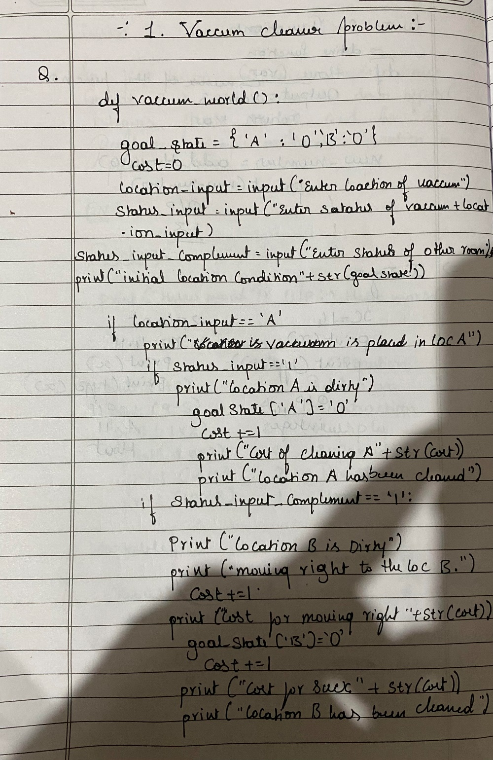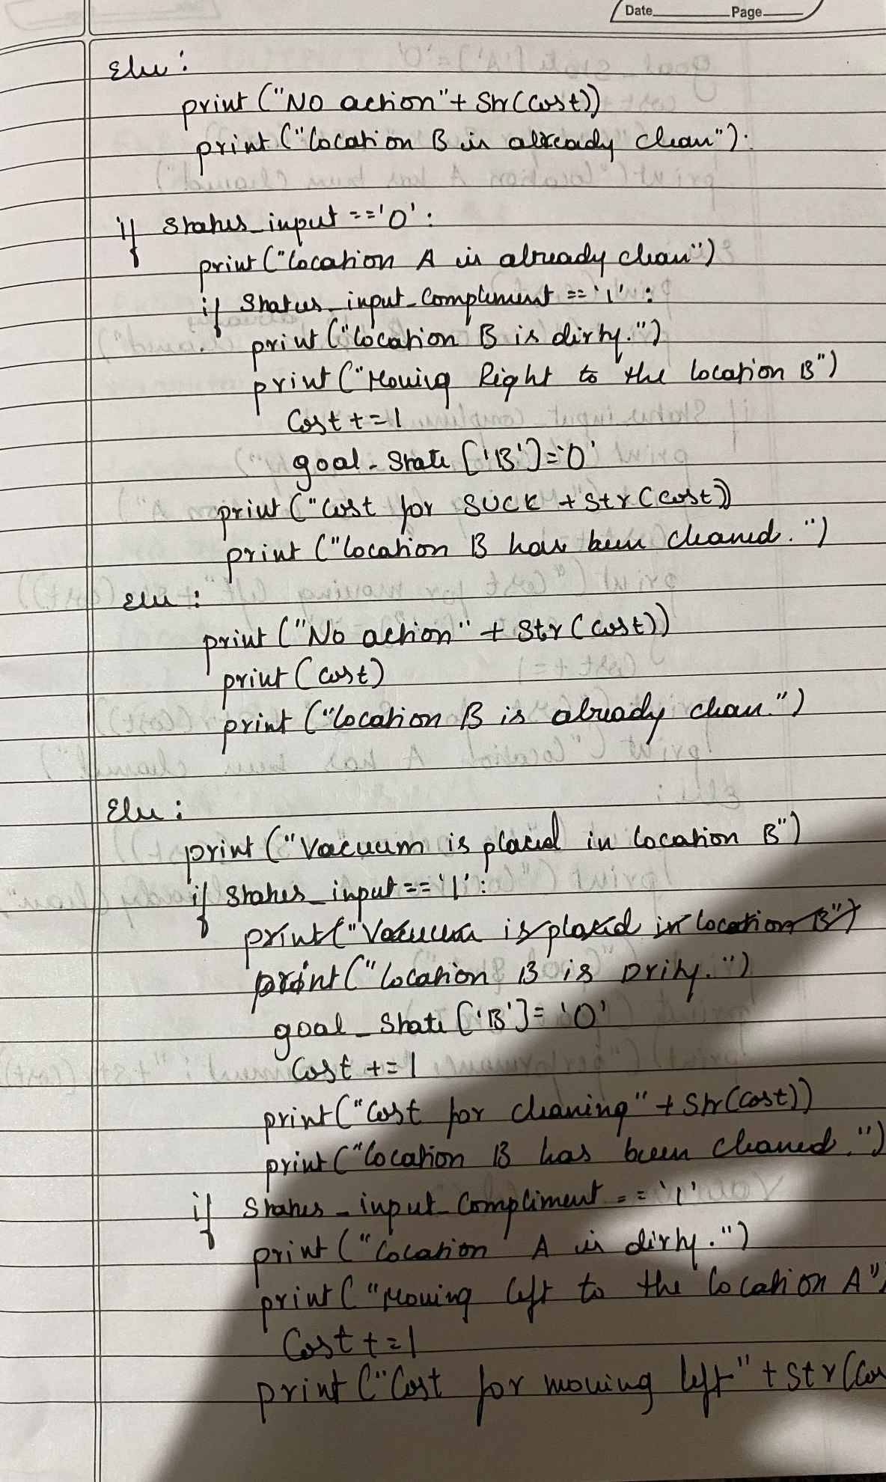

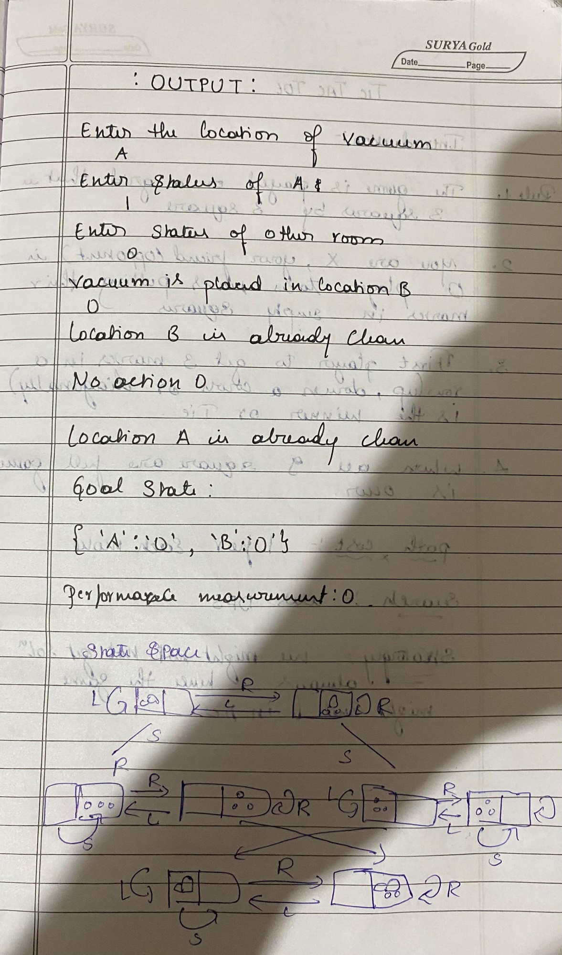

Code:

def vacuum_world():

# initializing goal_state

# 0 indicates Clean and 1 indicates Dirty

goal_state = {'A': '0', 'B': '0'}

cost = 0

location_input = input("Enter Location of Vacuum") #user_input of location vacuum is placed

status_input = input("Enter status of " + location_input) #user_input if location is dirty or clean

status_input_complement = input("Enter status of other room")

print("Initial Location Condition" + str(goal_state))

if location_input == 'A':

# Location A is Dirty.

print("Vacuum is placed in Location A")

if status_input == '1':

print("Location A is Dirty.")

# suck the dirt and mark it as clean

goal_state['A'] = '0'

cost += 1 #cost for suck

print("Cost for CLEANING A " + str(cost))

print("Location A has been Cleaned.")

if status_input_complement == '1':

# if B is Dirty

print("Location B is Dirty.")

print("Moving right to the Location B. ")

cost += 1 #cost for moving right

print("COST for moving RIGHT" + str(cost))

# suck the dirt and mark it as clean

goal_state['B'] = '0'

cost += 1 #cost for suck

print("COST for SUCK " + str(cost))

print("Location B has been Cleaned. ")

else:

print("No action" + str(cost))

# suck and mark clean

print("Location B is already clean.")

if status_input == '0':

print("Location A is already clean ")

if status_input_complement == '1':# if B is Dirty

print("Location B is Dirty.")

print("Moving RIGHT to the Location B. ")

cost += 1 #cost for moving right

print("COST for moving RIGHT " + str(cost))

# suck the dirt and mark it as clean

goal_state['B'] = '0'

cost += 1 #cost for suck

print("Cost for SUCK" + str(cost))

print("Location B has been Cleaned. ")

else:

print("No action " + str(cost))

print(cost)

# suck and mark clean

print("Location B is already clean.")

else:

print("Vacuum is placed in location B")

# Location B is Dirty.

if status_input == '1':

print("Location B is Dirty.")

# suck the dirt and mark it as clean

goal_state['B'] = '0'

cost += 1 # cost for suck

print("COST for CLEANING " + str(cost))

print("Location B has been Cleaned.")

if status_input_complement == '1':

# if A is Dirty

print("Location A is Dirty.")

print("Moving LEFT to the Location A. ")

cost += 1 # cost for moving right

print("COST for moving LEFT" + str(cost))

# suck the dirt and mark it as clean

goal_state['A'] = '0'

cost += 1 # cost for suck

print("COST for SUCK " + str(cost))

print("Location A has been Cleaned.")

else:

print(cost)

# suck and mark clean

print("Location B is already clean.")

if status_input_complement == '1': # if A is Dirty

print("Location A is Dirty.")

print("Moving LEFT to the Location A. ")

cost += 1 # cost for moving right

print("COST for moving LEFT " + str(cost))

# suck the dirt and mark it as clean

goal_state['A'] = '0'

cost += 1 # cost for suck

print("Cost for SUCK " + str(cost))

print("Location A has been Cleaned. ")

else:

print("No action " + str(cost))

# suck and mark clean

print("Location A is already clean.")

# done cleaning

print("GOAL STATE: ")

print(goal_state)

print("Performance Measurement: " + str(cost))

vacuum_world()

Output:

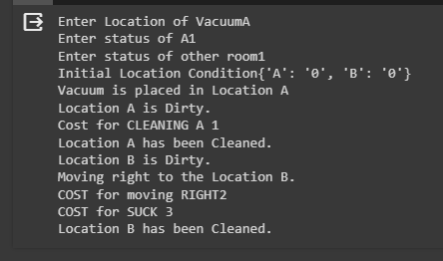

State-Space Diagram:

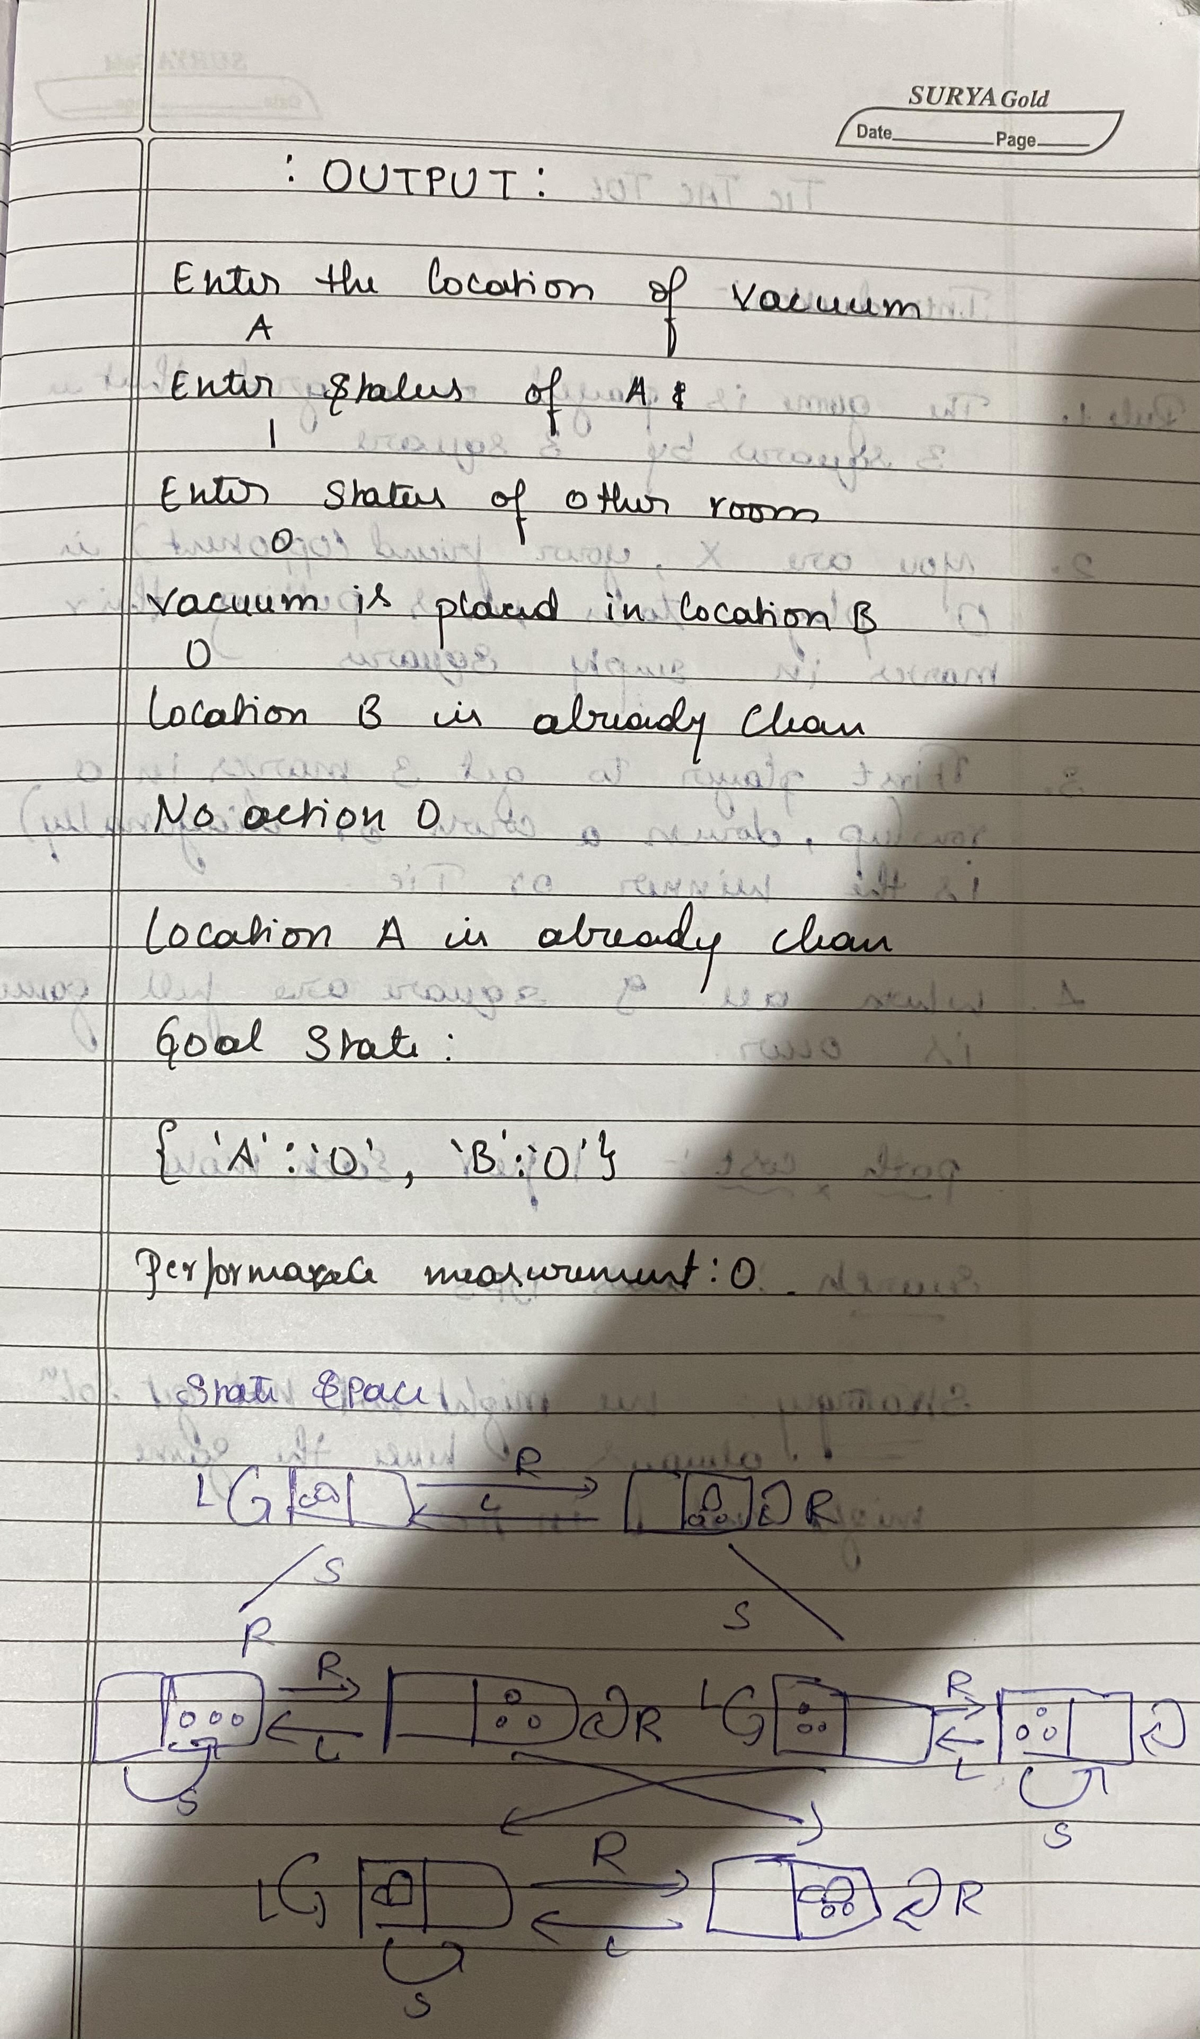

**Program-2**

Explore the working of Tic Tac Toe using Min max strategy

Algorithm:

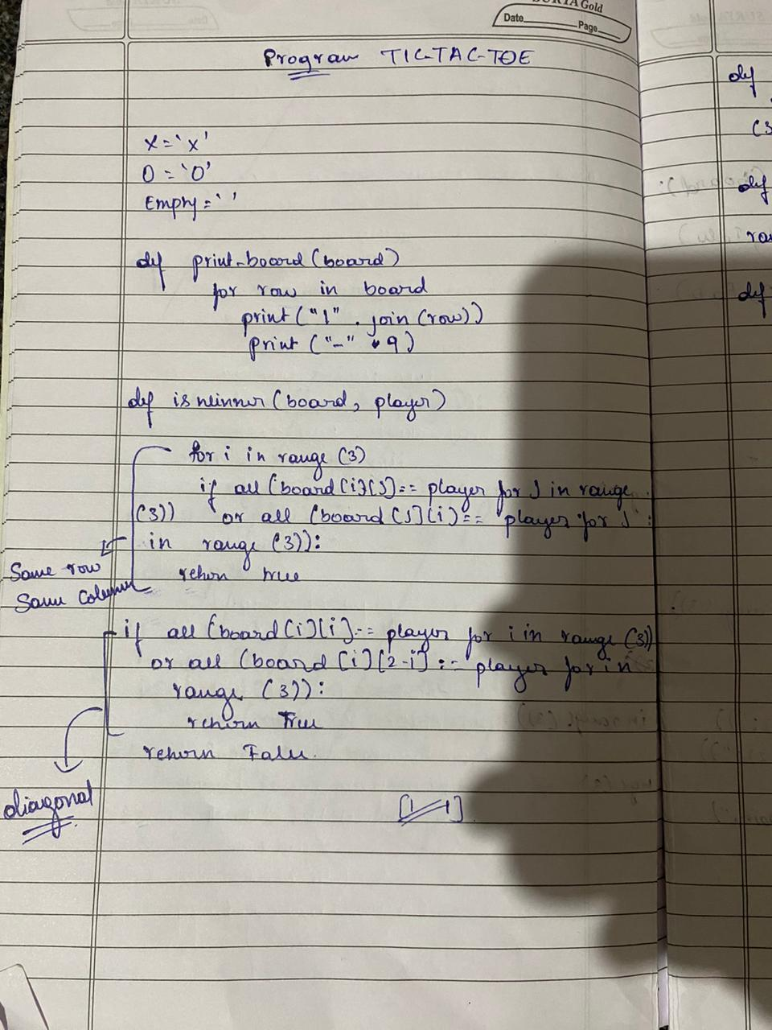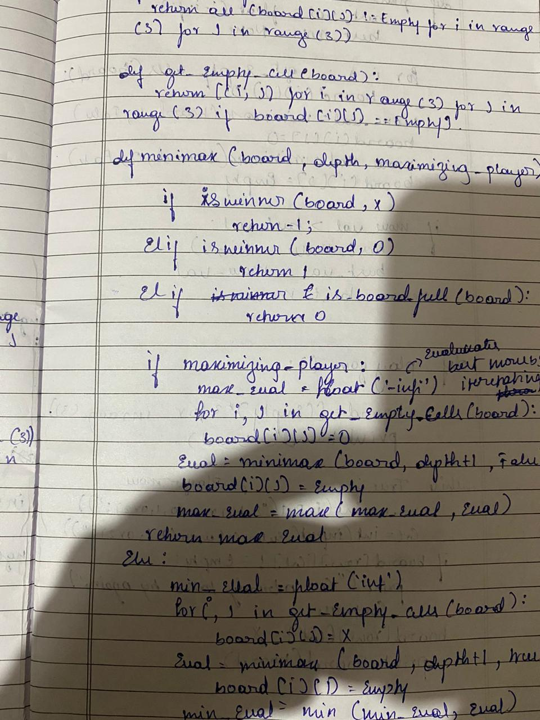

Code:

board = [[" ", " ", " "], [" ", " ", " "], [" ", " ", " "]]

print("0,0|0,1|0,2")

print("1,0|1,1|1,2")

print("2,0|,2,1|2,2 \n\n")

def print_board():

for row in board:

print("|".join(row))

print("-" * 5)

def check_winner(player):

for i in range(3):

if all([board[i][j] == player for j in range(3)]) or all([board[j][i] == player for j in range(3)]):

return True

if all([board[i][i] == player for i in range(3)]) or all([board[i][2 - i] == player for i in range(3)]):

return True

return False

def is_full():

return all([cell != " " for row in board for cell in row])

def minimax(depth, is_maximizing):

if check_winner("X"):

return -1

if check_winner("O"):

return 1

if is_full():

return 0

if is_maximizing:

max_eval = float("-inf")

for i in range(3):

for j in range(3):

if board[i][j] == " ":

board[i][j] = "O"

eval = minimax(depth + 1, False)

board[i][j] = " "

max_eval = max(max_eval, eval)

return max_eval

else:

min_eval = float("inf")

for i in range(3):

for j in range(3):

if board[i][j] == " ":

board[i][j] = "X"

eval = minimax(depth + 1, True)

board[i][j] = " "

min_eval = min(min_eval, eval)

return min_eval

def ai_move():

best_move = None

best_eval = float("-inf")

for i in range(3):

for j in range(3):

if board[i][j] == " ":

board[i][j] = "O"

eval = minimax(0, False)

board[i][j] = " "

if eval > best_eval:

best_eval = eval

best_move = (i, j)

return best_move

while not is_full() and not check_winner("X") and not check_winner("O"):

print_board()

row = int(input("Enter row (0, 1, or 2): "))

col = int(input("Enter column (0, 1, or 2): "))

if board[row][col] == " ":

board[row][col] = "X"

if check_winner("X"):

print_board()

print("You win!")

break

if is_full():

print_board()

print("It's a draw!")

break

ai_row, ai_col = ai_move()

board[ai_row][ai_col] = "O"

if check_winner("O"):

print_board()

print("AI wins!")

break

else:

print("Cell is already occupied. Try again.")

Output:

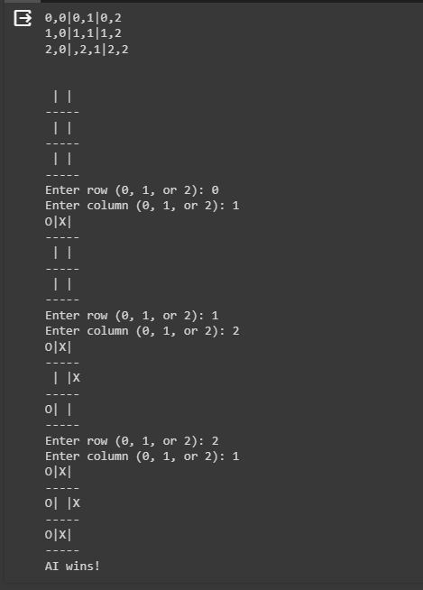

State-Space Diagram:

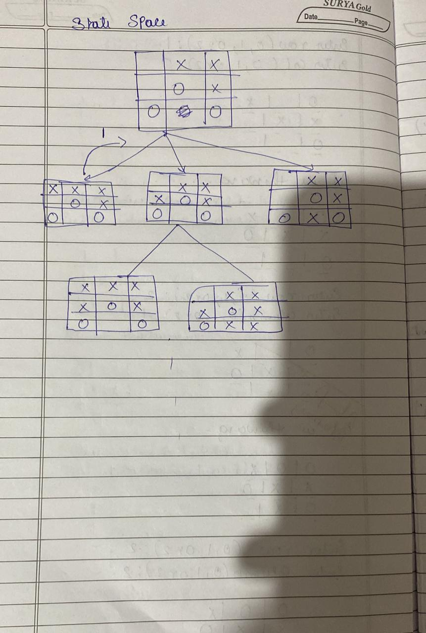

**Program-3**

Implement the 8 Puzzle Breadth First Search Algorithm.

Algorithm:

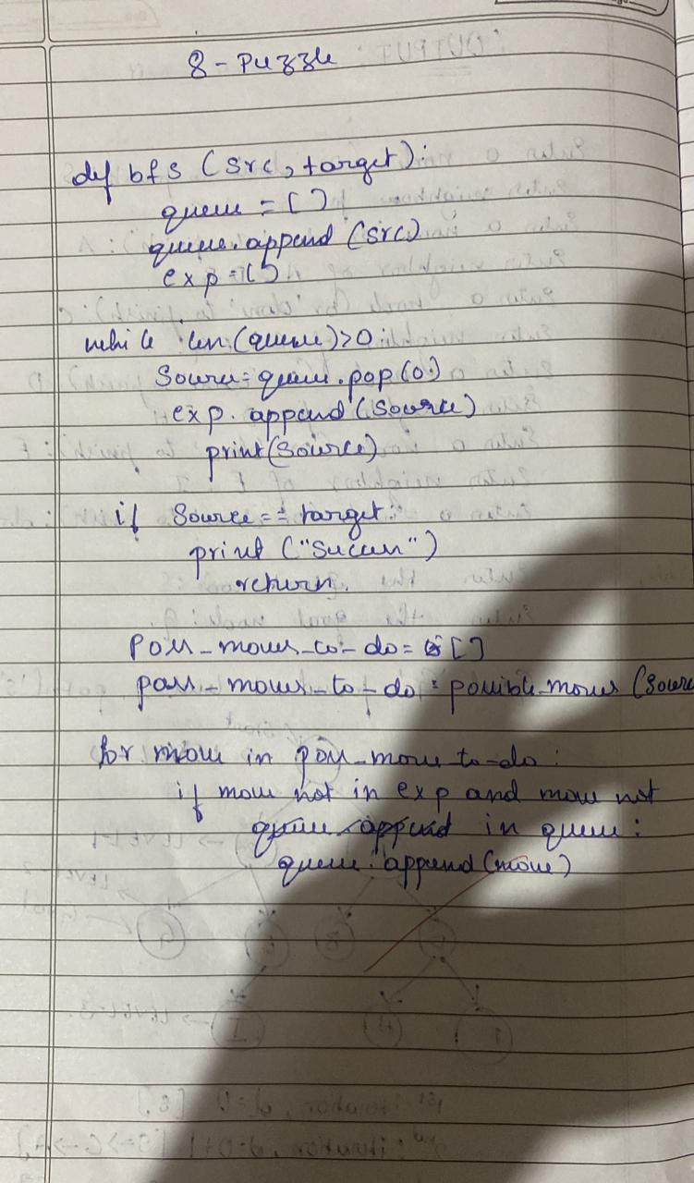

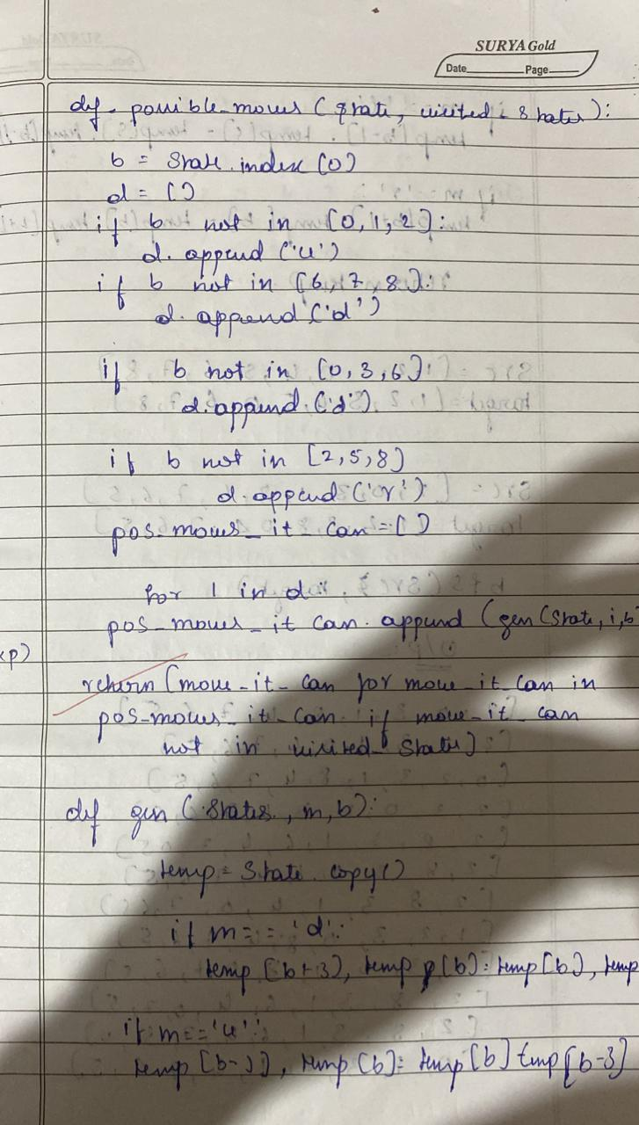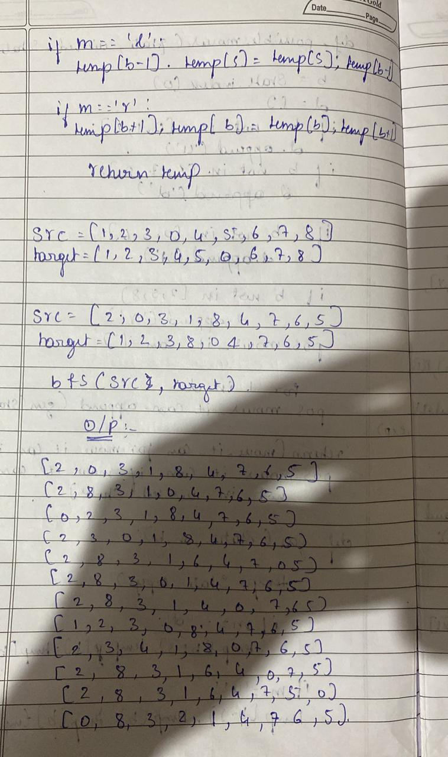

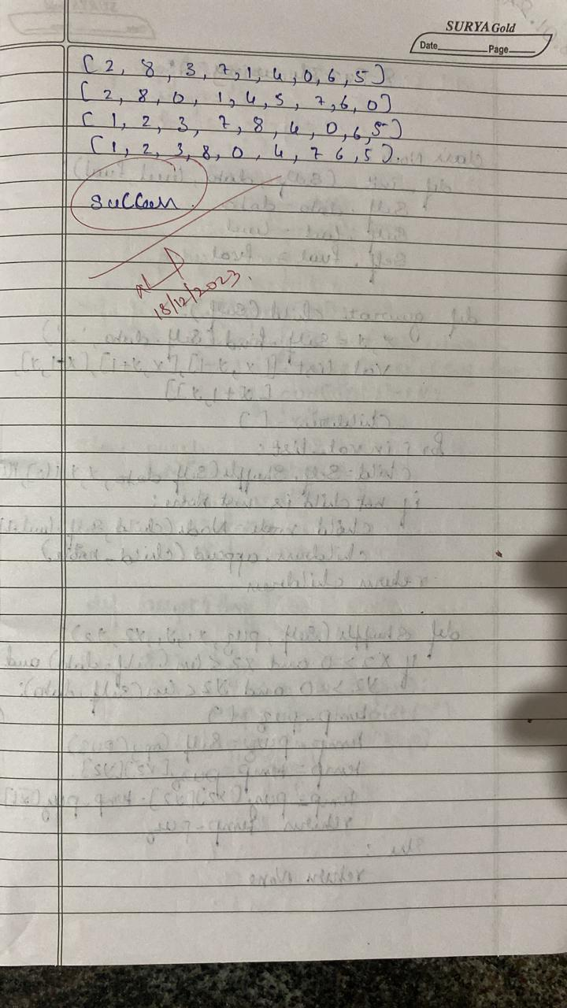

Code:

import numpy as np

import pandas as pd

import os

def gen(state, m, b):

temp = state.copy()

if m == 'd':

temp[b + 3], temp[b] = temp[b], temp[b + 3]

elif m == 'u':

temp[b - 3], temp[b] = temp[b], temp[b - 3]

elif m == 'l':

temp[b - 1], temp[b] = temp[b], temp[b - 1]

elif m == 'r':

temp[b + 1], temp[b] = temp[b], temp[b + 1]

return temp # Return the modified state

def possible_moves(state, visited_states):

b = state.index(0)

d = []

if b not in [0, 1, 2]:

d.append('u')

if b not in [6, 7, 8]:

d.append('d')

if b not in [0, 3, 6]:

d.append('l')

if b not in [2, 5, 8]:

d.append('r')

pos_moves_it_can = []

for i in d:

pos_moves_it_can.append(gen(state, i, b))

return [move_it_can for move_it_can in pos_moves_it_can if move_it_can not in visited_states]

def bfs(src, target):

queue = []

queue.append(src)

cost=0

exp = []

while len(queue) > 0:

source = queue.pop(0)

cost+=1

exp.append(source)

print(source[0],'|',source[1],'|',source[2])

print(source[3],'|',source[4],'|', source[5])

print(source[6],'|', source[7],'|',source[8])

print()

if source == target:

print("success")

print("Cost:",cost)

return

poss_moves_to_do = possible_moves(source, exp)

for move in poss_moves_to_do:

if move not in exp and move not in queue:

queue.append(move)

src = [1, 2, 3, 5, 6, 0, 7, 8, 4]

target = [1, 2, 3, 5,8, 6, 0, 7, 4]

bfs(src, target)

Output:

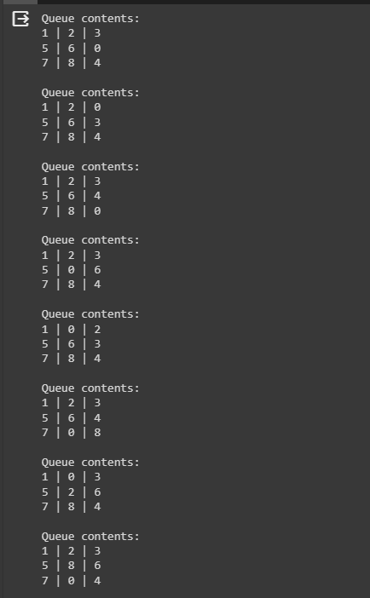

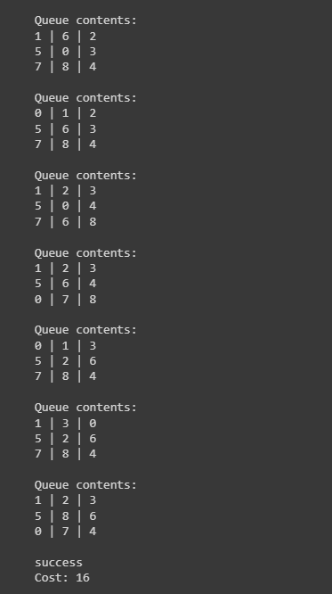

**Program-4**

Implement Iterative deepening search algorithm.

Algorithm:

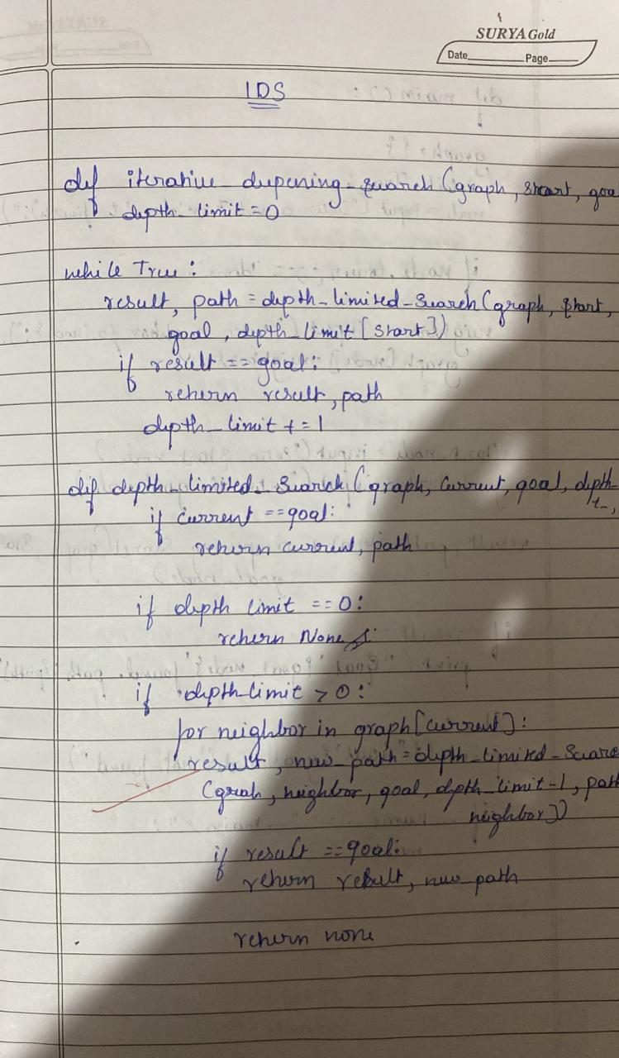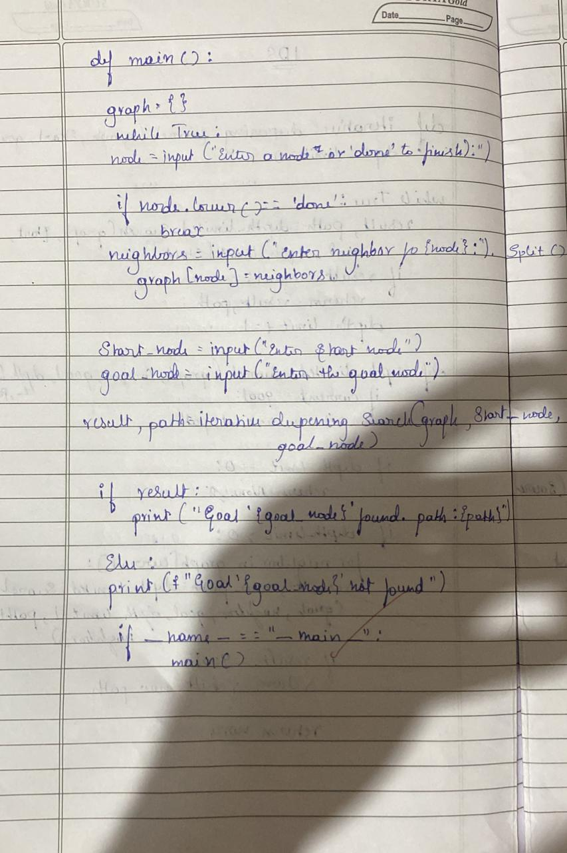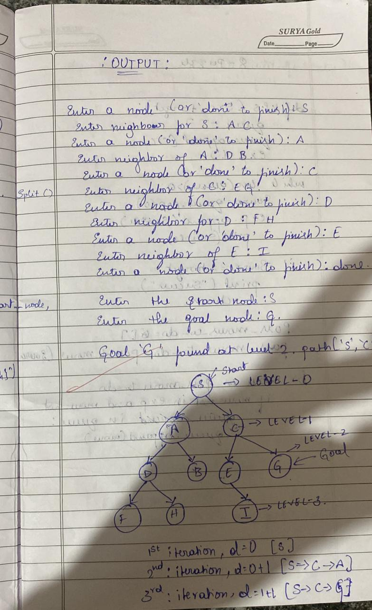

Code:

from collections import defaultdict

cost=0

class Graph:

def __init__(self,vertices):

self.V = vertices

self.graph = defaultdict(list)

def addEdge(self,u,v):

self.graph[u].append(v)

def DLS(self,src,target,maxDepth):

if src == target :

return True

if maxDepth <= 0 : return False

for i in self.graph[src]:

if(self.DLS(i,target,maxDepth-1)):

return True

return False

def IDDFS(self,src, target, maxDepth):

for i in range(maxDepth):

if (self.DLS(src, target, i)):

return True

return False

src = 0

pin=int(input('Enter the number of verices:'))

g=Graph(pin)

while(pin>1):

e1=int(input('Enter the first vertex:'))

e2=int(input('Enter the second vertex:'))

g.addEdge(e1,e2)

pin-=1

target=int(input('Enter the target vertex:'))

maxDepth=int(input('Enter the max depth:'))

pen=1

while(pen<=maxDepth):

if g.IDDFS(src, target, pen) == True:

print ("Target is reachable from source within",pen)

print("COST:6")

else :

print ("Target is NOT reachable from source within",pen)

pen+=1

Output:

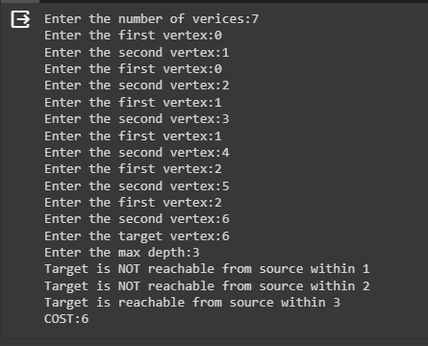

State-Space Diagram:



**Program-5**

Implement A* for 8 puzzle problem

Algorithm:

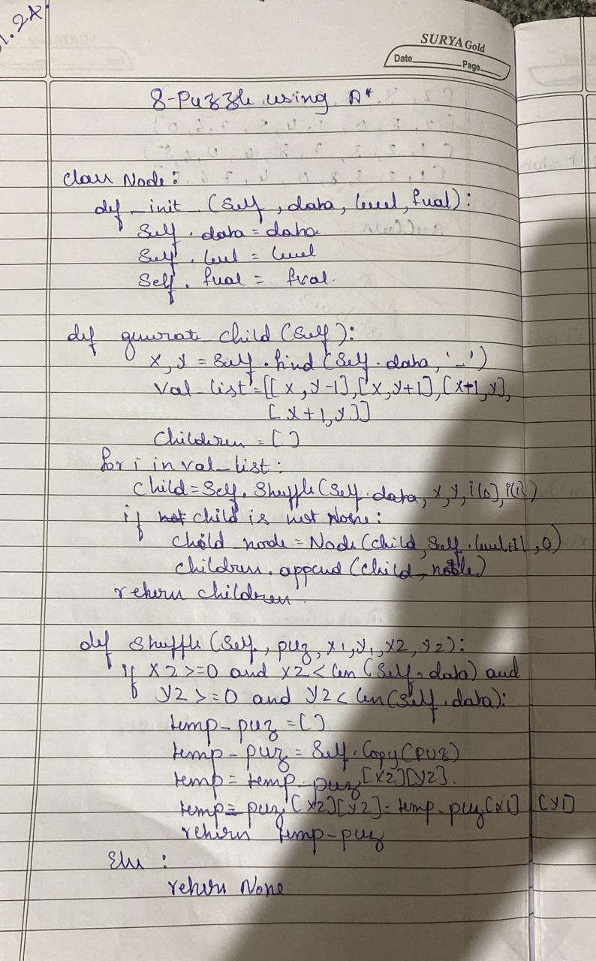

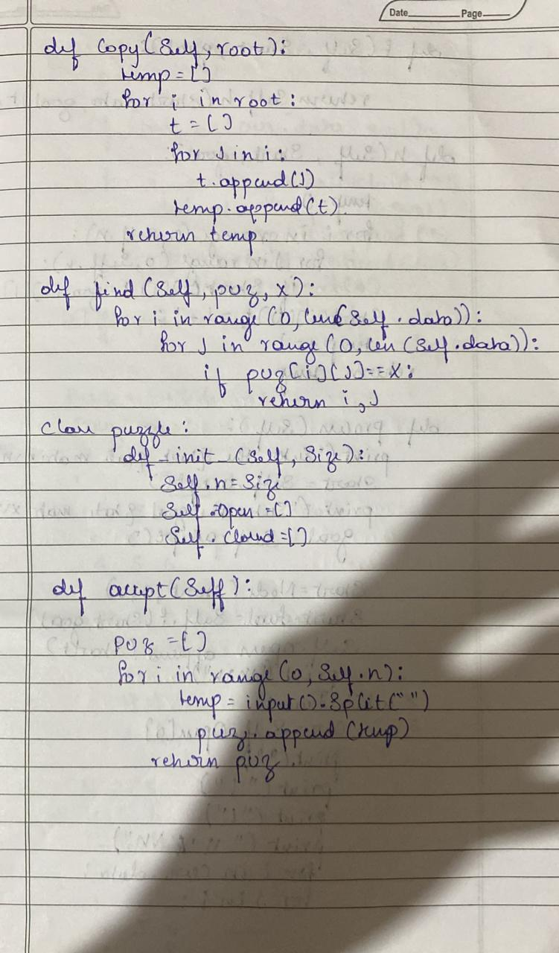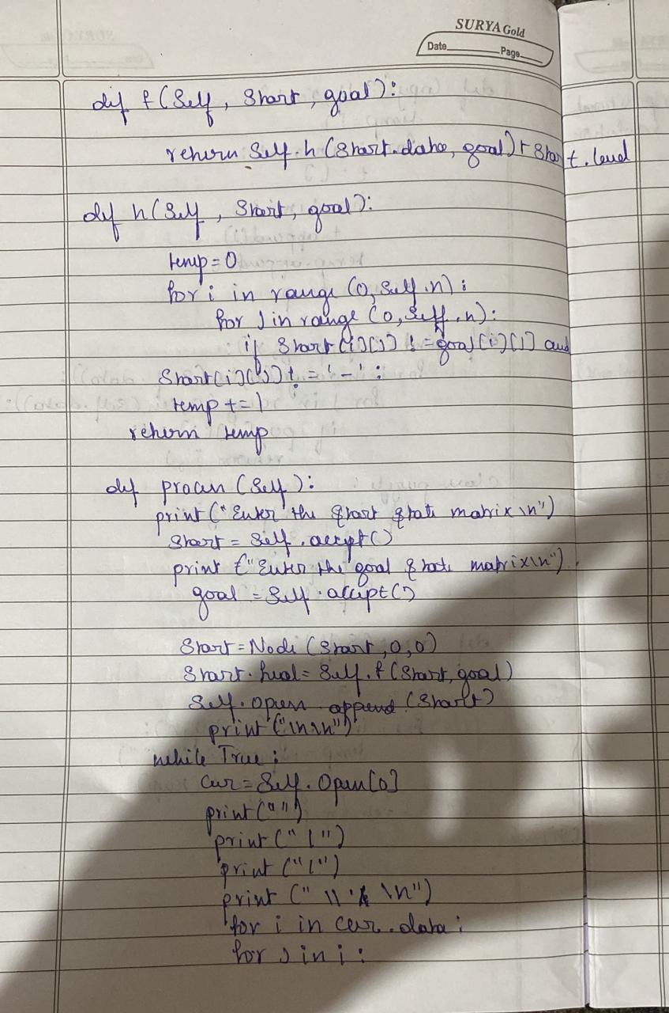

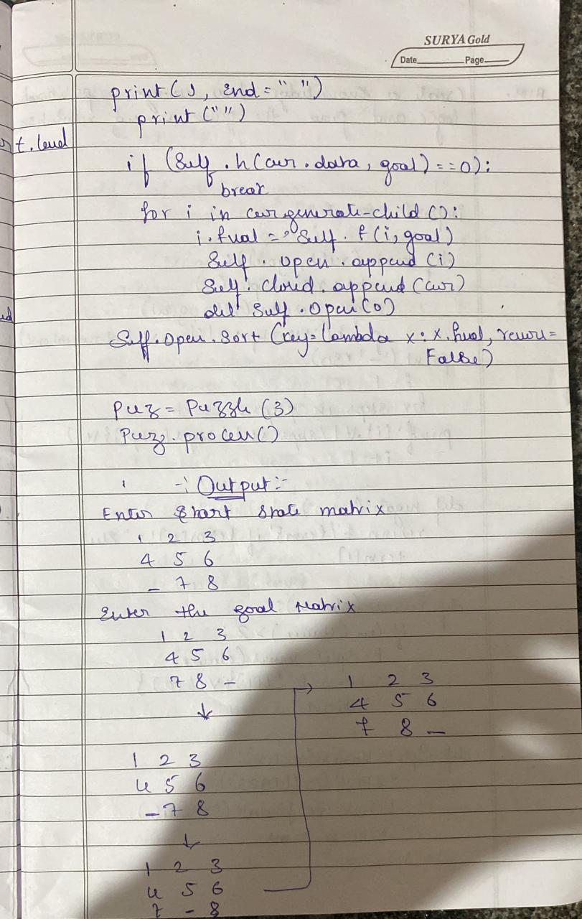

Code:

from copy import deepcopy

import numpy as np

import time

def bestsolution(state):

bestsol = np.array([], int).reshape(-1, 9)

count = len(state) - 1

while count != -1:

bestsol = np.insert(bestsol, 0, state[count]['puzzle'], 0)

count = (state[count]['parent'])

return bestsol.reshape(-1, 3, 3)

def all(checkarray):

set=[]

for it in set:

for checkarray in it:

return 1

else:

return 0

def manhattan(puzzle, goal):

a = abs(puzzle // 3 - goal // 3)

b = abs(puzzle % 3 - goal % 3)

mhcost = a + b

return sum(mhcost[1:])

# will calcuates the number of misplaced tiles in the current state as compared to the goal state

def misplaced_tiles(puzzle,goal):

mscost = np.sum(puzzle != goal) - 1

return mscost if mscost > 0 else 0

#3[on_true] if [expression] else [on_false]

# will indentify the coordinates of each of goal or initial state values

def coordinates(puzzle):

pos = np.array(range(9))

for p, q in enumerate(puzzle):

pos[q] = p

return pos

# start of 8 puzzle evaluvation, using Manhattan heuristics

def evaluvate(puzzle, goal):

steps = np.array([('up', [0, 1, 2], -3),('down', [6, 7, 8], 3),('left', [0, 3, 6], -1),('right', [2, 5, 8], 1)],

dtype = [('move', str, 1),('position', list),('head', int)])

dtstate = [('puzzle', list),('parent', int),('gn', int),('hn', int)]

# initializing the parent, gn and hn, where hn is manhattan distance function call

costg = coordinates(goal)

parent = -1

gn = 0

hn = manhattan(coordinates(puzzle), costg)

state = np.array([(puzzle, parent, gn, hn)], dtstate)

# We make use of priority queues with position as keys and fn as value.

dtpriority = [('position', int),('fn', int)]

priority = np.array( [(0, hn)], dtpriority)

while 1:

priority = np.sort(priority, kind='mergesort', order=['fn', 'position'])

position, fn = priority[0]

priority = np.delete(priority, 0, 0)

# sort priority queue using merge sort,the first element is picked for exploring remove from queue what we are exploring

puzzle, parent, gn, hn = state[position]

puzzle = np.array(puzzle)

# Identify the blank square in input

blank = int(np.where(puzzle == 0)[0])

gn = gn + 1

c = 1

start_time = time.time()

for s in steps:

c = c + 1

if blank not in s['position']:

# generate new state as copy of current

openstates = deepcopy(puzzle)

openstates[blank], openstates[blank + s['head']] = openstates[blank + s['head']], openstates[blank]

# The all function is called, if the node has been previously explored or not

if ~(np.all(list(state['puzzle']) == openstates, 1)).any():

end_time = time.time()

if (( end_time - start_time ) > 2):

print(" The 8 puzzle is unsolvable ! \n")

exit

# calls the manhattan function to calcuate the cost

hn = manhattan(coordinates(openstates), costg)

# generate and add new state in the list

q = np.array([(openstates, position, gn, hn)], dtstate)

state = np.append(state, q, 0)

# f(n) is the sum of cost to reach node and the cost to rech fromt he node to the goal state

fn = gn + hn

q = np.array([(len(state) - 1, fn)], dtpriority)

priority = np.append(priority, q, 0)

# Checking if the node in openstates are matching the goal state.

if np.array_equal(openstates, goal):

print(' The 8 puzzle is solvable ! \n')

return state, len(priority)

return state, len(priority)

# start of 8 puzzle evaluvation, using Misplaced tiles heuristics

def evaluvate_misplaced(puzzle, goal):

steps = np.array([('up', [0, 1, 2], -3),('down', [6, 7, 8], 3),('left', [0, 3, 6], -1),('right', [2, 5, 8], 1)],

dtype = [('move', str, 1),('position', list),('head', int)])

dtstate = [('puzzle', list),('parent', int),('gn', int),('hn', int)]

costg = coordinates(goal)

# initializing the parent, gn and hn, where hn is misplaced_tiles function call

parent = -1

gn = 0

hn = misplaced_tiles(coordinates(puzzle), costg)

state = np.array([(puzzle, parent, gn, hn)], dtstate)

# We make use of priority queues with position as keys and fn as value.

dtpriority = [('position', int),('fn', int)]

priority = np.array([(0, hn)], dtpriority)

while 1:

priority = np.sort(priority, kind='mergesort', order=['fn', 'position'])

position, fn = priority[0]

# sort priority queue using merge sort,the first element is picked for exploring.

priority = np.delete(priority, 0, 0)

puzzle, parent, gn, hn = state[position]

puzzle = np.array(puzzle)

# Identify the blank square in input

blank = int(np.where(puzzle == 0)[0])

# Increase cost g(n) by 1

gn = gn + 1

c = 1

start_time = time.time()

for s in steps:

c = c + 1

if blank not in s['position']:

# generate new state as copy of current

openstates = deepcopy(puzzle)

openstates[blank], openstates[blank + s['head']] = openstates[blank + s['head']], openstates[blank]

# The check function is called, if the node has been previously explored or not.

if ~(np.all(list(state['puzzle']) == openstates, 1)).any():

end_time = time.time()

if (( end_time - start_time ) > 2):

print(" The 8 puzzle is unsolvable \n")

break

# calls the Misplaced_tiles function to calcuate the cost

hn = misplaced_tiles(coordinates(openstates), costg)

# generate and add new state in the list

q = np.array([(openstates, position, gn, hn)], dtstate)

state = np.append(state, q, 0)

# f(n) is the sum of cost to reach node and the cost to rech fromt he node to the goal state

fn = gn + hn

q = np.array([(len(state) - 1, fn)], dtpriority)

priority = np.append(priority, q, 0)

# Checking if the node in openstates are matching the goal state.

if np.array_equal(openstates, goal):

print(' The 8 puzzle is solvable \n')

return state, len(priority)

return state, len(priority)

# ---------- Program start -----------------

# User input for initial state

puzzle = []

print(" Input vals from 0-8 for start state ")

for i in range(0,9):

x = int(input("enter vals :"))

puzzle.append(x)

# User input of goal state

goal = []

print(" Input vals from 0-8 for goal state ")

for i in range(0,9):

x = int(input("Enter vals :"))

goal.append(x)

n = int(input("1. Manhattan distance \n2. Misplaced tiles"))

if(n ==1 ):

state, visited = evaluvate(puzzle, goal)

bestpath = bestsolution(state)

print(str(bestpath).replace('[', ' ').replace(']', ''))

totalmoves = len(bestpath) - 1

print('Steps to reach goal:',totalmoves)

visit = len(state) - visited

print('Total nodes visited: ',visit, "\n")

print('Total generated:', len(state))

if(n == 2):

state, visited = evaluvate_misplaced(puzzle, goal)

bestpath = bestsolution(state)

print(str(bestpath).replace('[', ' ').replace(']', ''))

totalmoves = len(bestpath) - 1

print('Steps to reach goal:',totalmoves)

visit = len(state) - visited

print('Total nodes visited: ',visit, "\n")

print('Total generated:', len(state))

Output:

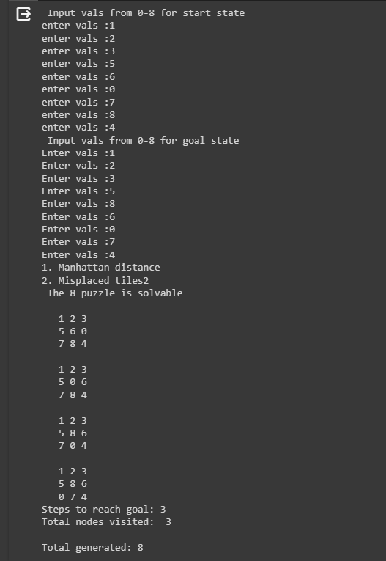

**Program-6**

Create a knowledge base using prepositional logic and show that the given query entails the knowledge base or not .

Algorithm:

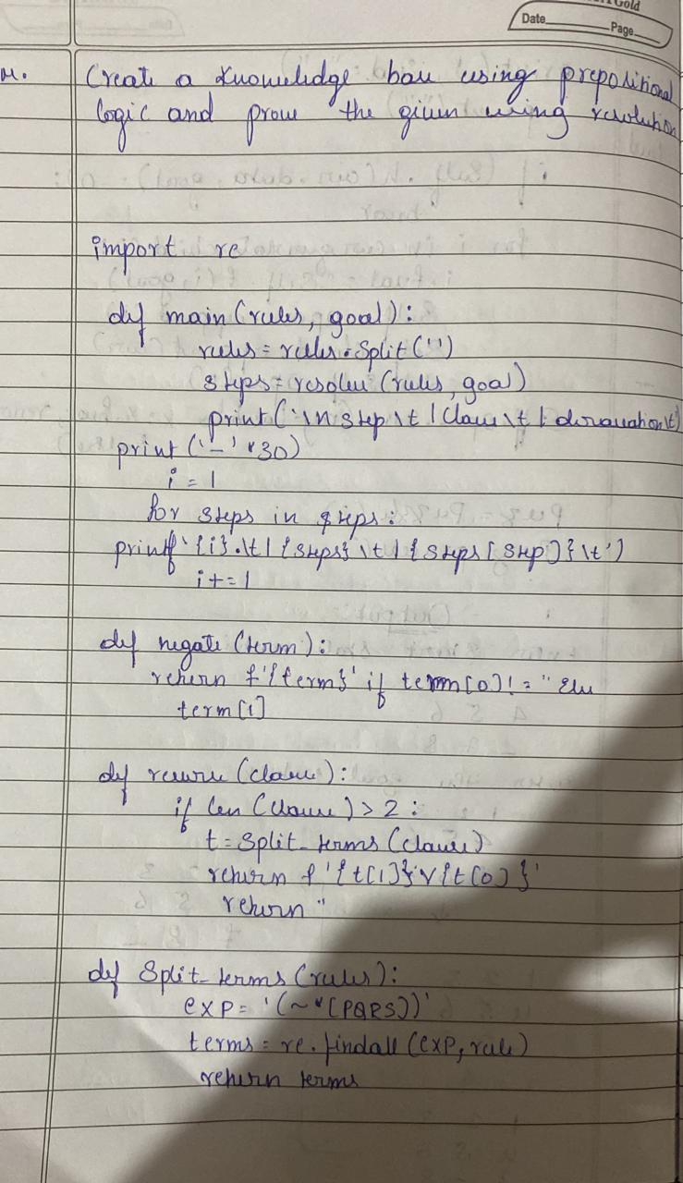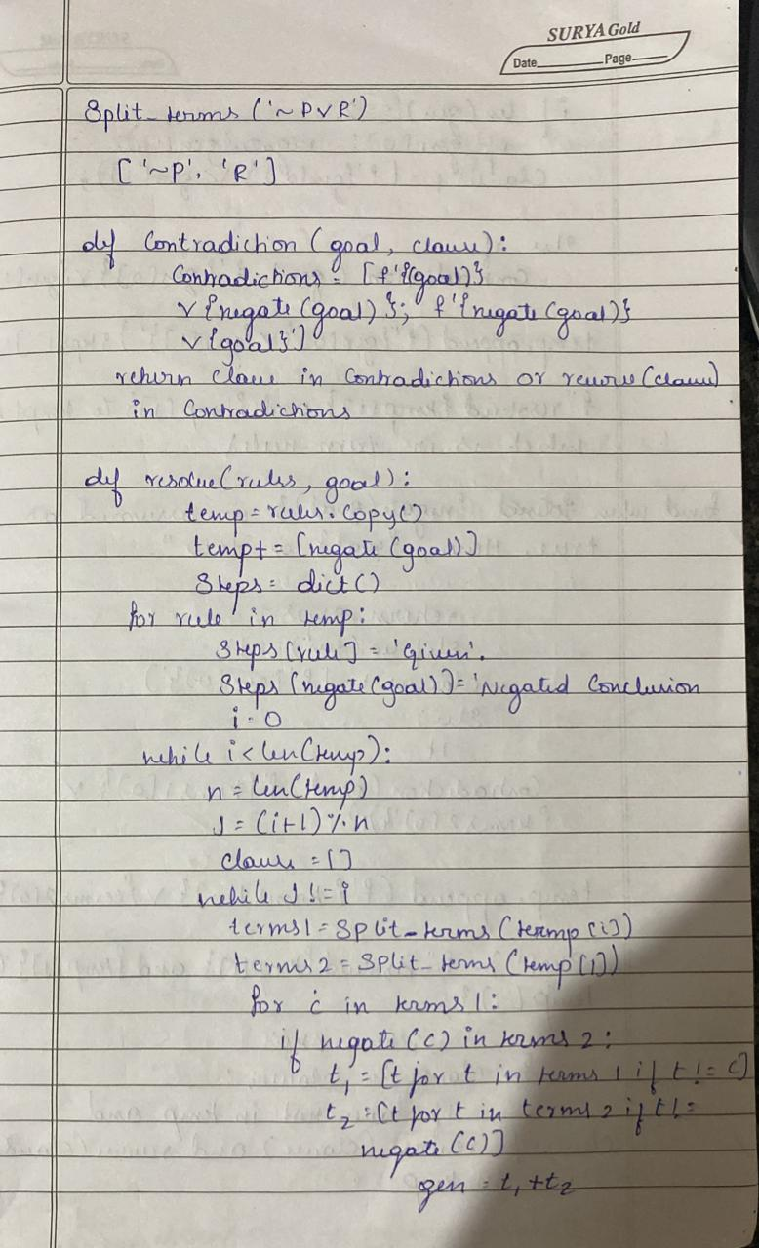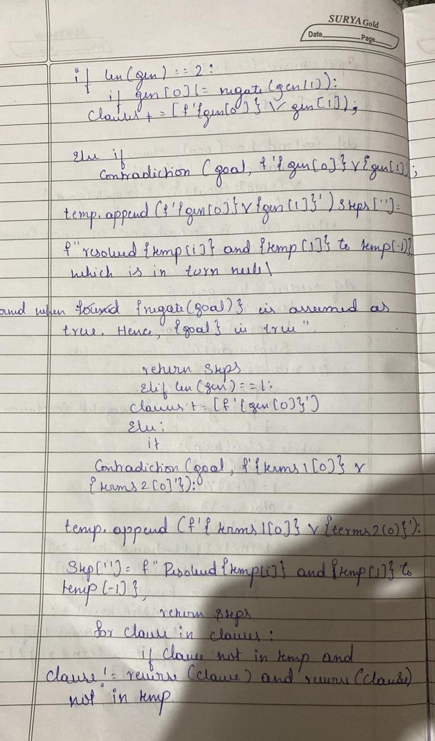

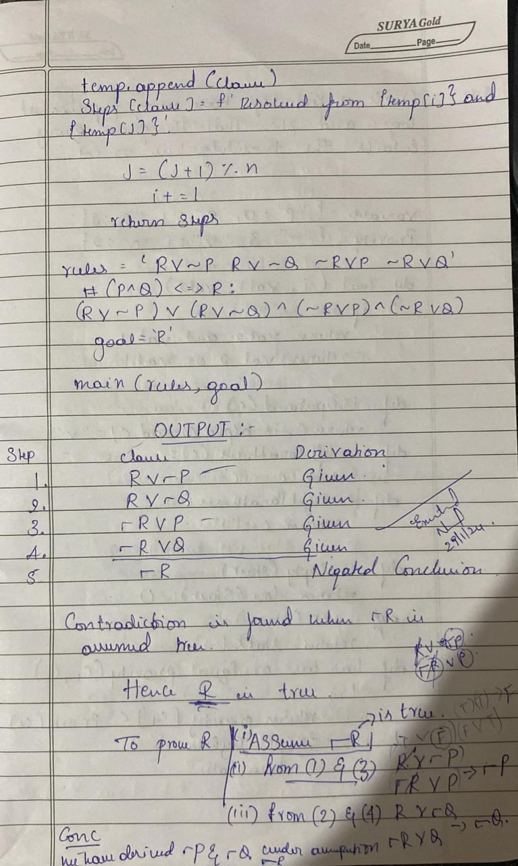Code:

combinations=[(True,True, True),(True,True,False),(True,False,True),(True,False, False),(False,True, True),(False,True, False),(False, False,True),(False,False, False)]

variable={'p':0,'q':1, 'r':2}

kb=''

q=''

priority={'~':3,'v':1,'^':2}

def input_rules():

global kb, q

kb = (input("Enter rule: "))

q = input("Enter the Query: ")

def entailment():

global kb, q

print('*'*10+"Truth Table Reference"+'*'*10)

print('kb','alpha')

print('*'*10)

for comb in combinations:

s = evaluatePostfix(toPostfix(kb), comb)

f = evaluatePostfix(toPostfix(q), comb)

print(s, f)

print('-'*10)

if s and not f:

return False

return True

def isOperand(c):

return c.isalpha() and c!='v'

def isLeftParanthesis(c):

return c == '('

def isRightParanthesis(c):

return c == ')'

def isEmpty(stack):

return len(stack) == 0

def peek(stack):

return stack[-1]

def hasLessOrEqualPriority(c1, c2):

try:

return priority[c1]<=priority[c2]

except KeyError:

return False

def toPostfix(infix):

stack = []

postfix = ''

for c in infix:

if isOperand(c):

postfix += c

else:

if isLeftParanthesis(c):

stack.append(c)

elif isRightParanthesis(c):

operator = stack.pop()

while not isLeftParanthesis(operator):

postfix += operator

operator = stack.pop()

else:

while (not isEmpty(stack)) and hasLessOrEqualPriority(c, peek(stack)):

postfix += stack.pop()

stack.append(c)

while (not isEmpty(stack)):

postfix += stack.pop()

return postfix

def evaluatePostfix(exp, comb):

stack = []

for i in exp:

if isOperand(i):

stack.append(comb[variable[i]])

elif i == '~':

val1 = stack.pop()

stack.append(not val1)

else:

val1 = stack.pop()

val2 = stack.pop()

stack.append(_eval(i,val2,val1))

return stack.pop()

def _eval(i, val1, val2):

if i == '^':

return val2 and val1

return val2 or val1

input_rules()

ans = entailment()

if ans:

print("The Knowledge Base entails query")

else:

print("The Knowledge Base does not entail query")

Output:

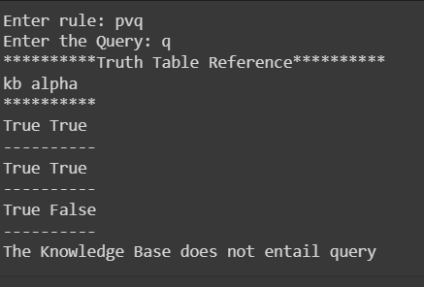

Proof:



**Program-7**

Create a knowledge base using prepositional logic and prove the given query using resolution

Algorithm:

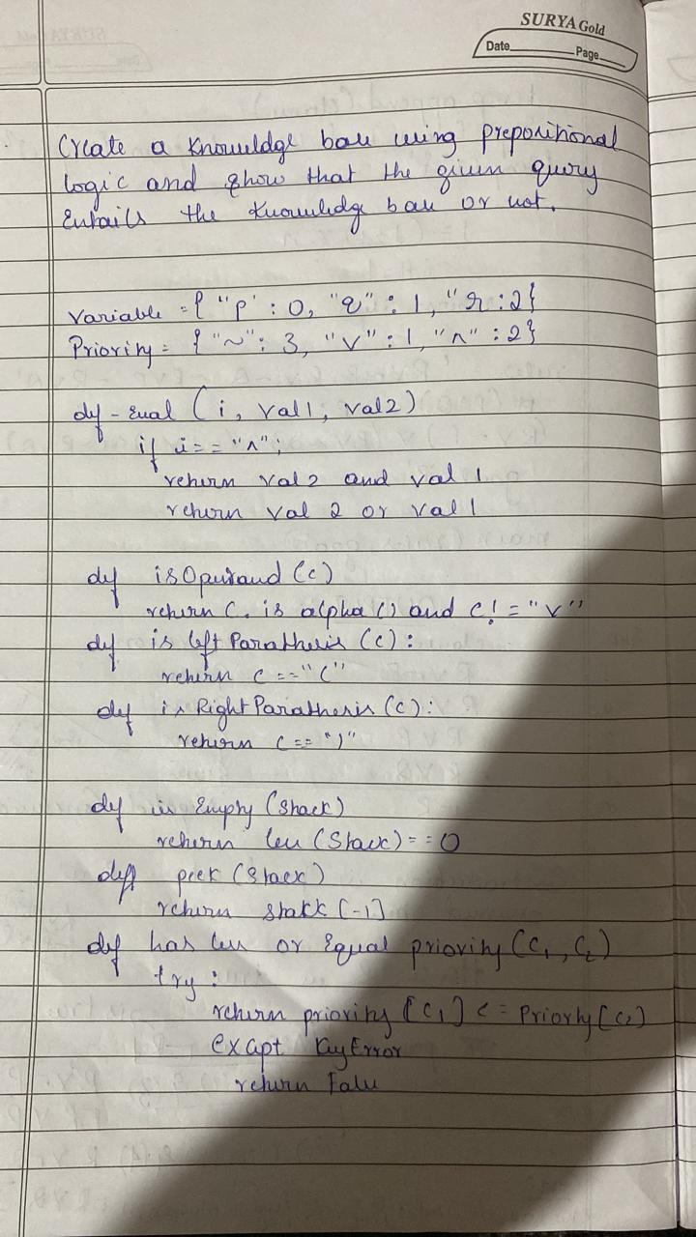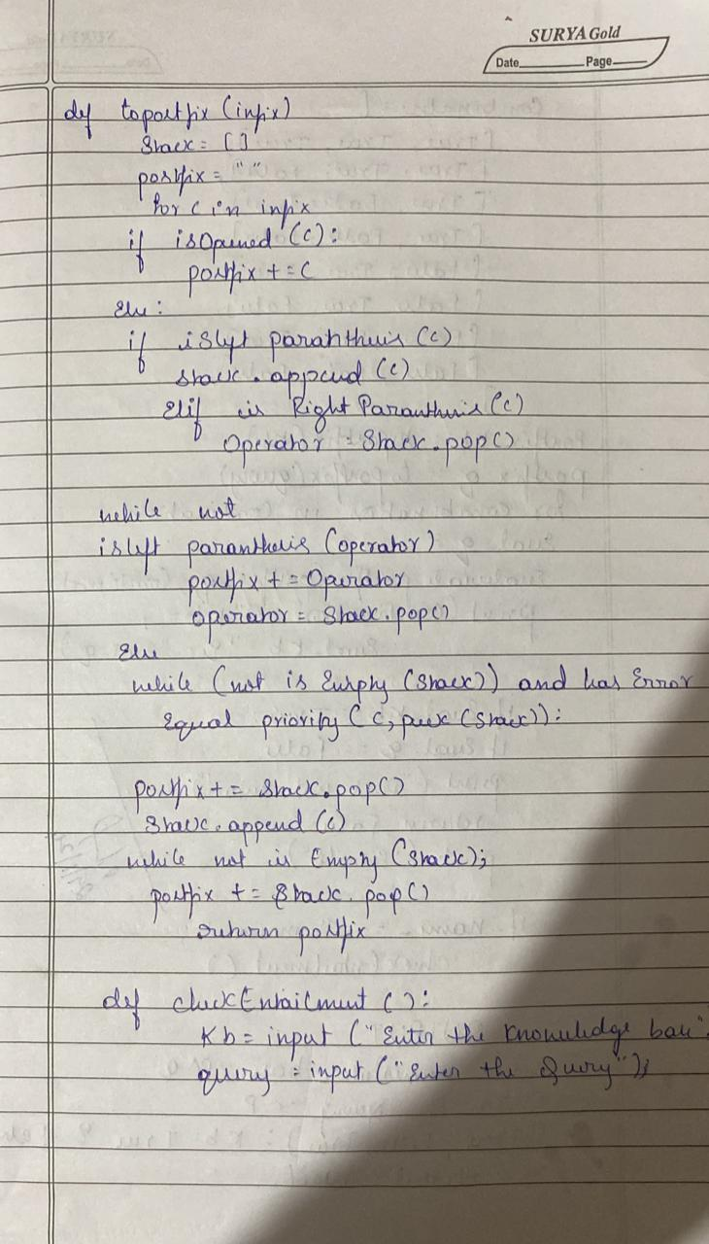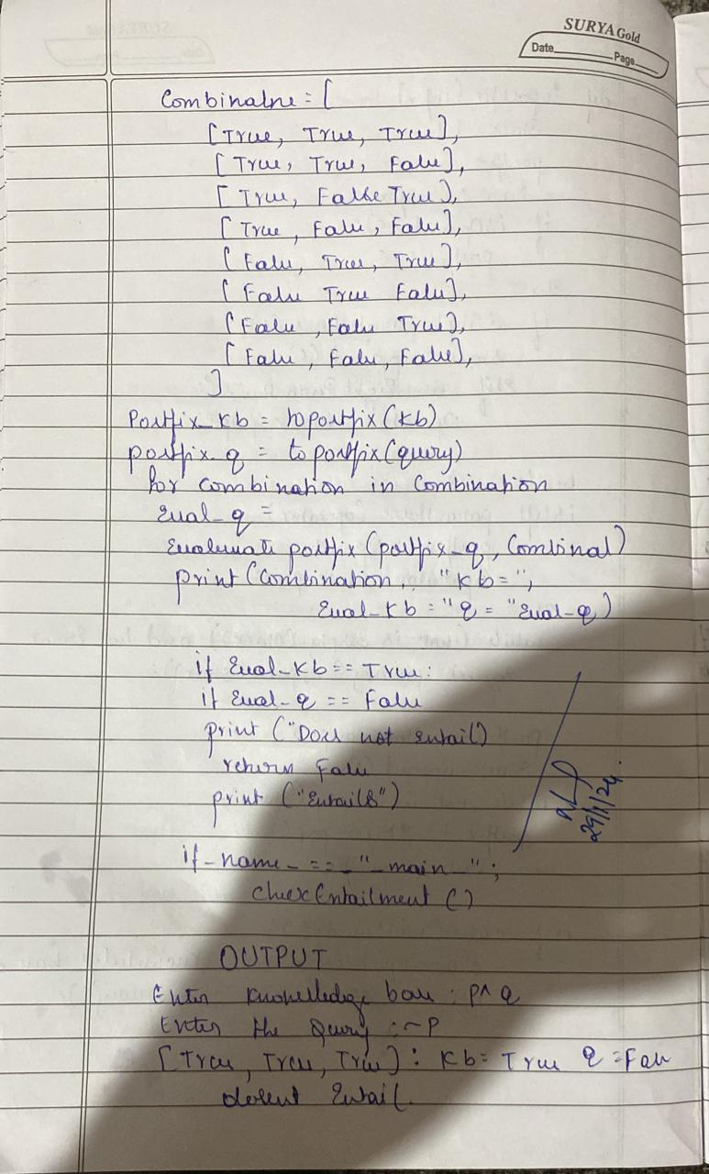

Code:

kb = []

def CLEAR():

global kb

kb = []

def TELL(sentence):

global kb

# If the sentence is a clause, insert directly.

if isClause(sentence):

kb.append(sentence)

# If not, convert to CNF, and then insert clauses one by one.

else:

sentenceCNF = convertCNF(sentence)

if not sentenceCNF:

print("Illegal input")

return

# Insert clauses one by one when there are multiple clauses

if isAndList(sentenceCNF):

for s in sentenceCNF[1:]:

kb.append(s)

else:

kb.append(sentenceCNF)

def ASK(sentence):

global kb

# Negate the sentence, and convert it to CNF accordingly.

if isClause(sentence):

neg = negation(sentence)

else:

sentenceCNF = convertCNF(sentence)

if not sentenceCNF:

print("Illegal input")

return

neg = convertCNF(negation(sentenceCNF))

# Insert individual clauses that we need to ask to ask_list.

ask_list = []

if isAndList(neg):

for n in neg[1:]:

nCNF = makeCNF(n)

if type(nCNF).__name__ == 'list':

ask_list.insert(0, nCNF)

else:

ask_list.insert(0, nCNF)

else:

ask_list = [neg]

clauses = ask_list + kb[:]

while True:

new_clauses = []

for c1 in clauses:

for c2 in clauses:

if c1 is not c2:

resolved = resolve(c1, c2)

if resolved == False:

continue

if resolved == []:

return True

new_clauses.append(resolved)

if len(new_clauses) == 0:

return False

new_in_clauses = True

for n in new_clauses:

if n not in clauses:

new_in_clauses = False

clauses.append(n)

if new_in_clauses:

return False

return False

def resolve(arg_one, arg_two):

resolved = False

s1 = make_sentence(arg_one)

s2 = make_sentence(arg_two)

resolve_s1 = None

resolve_s2 = None

# Two for loops that iterate through the two clauses.

for i in s1:

if isNotList(i):

a1 = i[1]

a1_not = True

else:

a1 = i

a1_not = False

for j in s2:

if isNotList(j):

a2 = j[1]

a2_not = True

else:

a2 = j

a2_not = False

# cancel out two literals such as 'a' $ ['not', 'a']

if a1 == a2:

if a1_not != a2_not:

# Return False if resolution already happend

# but contradiction still exists.

if resolved:

return False

else:

resolved = True

resolve_s1 = i

resolve_s2 = j

break

# Return False if not resolution happened

if not resolved:

return False

# Remove the literals that are canceled

s1.remove(resolve_s1)

s2.remove(resolve_s2)

# # Remove duplicates

result = clear_duplicate(s1 + s2)

# Format the result.

if len(result) == 1:

return result[0]

elif len(result) > 1:

result.insert(0, 'or')

return result

def make_sentence(arg):

if isLiteral(arg) or isNotList(arg):

return [arg]

if isOrList(arg):

return clear_duplicate(arg[1:])

return

def clear_duplicate(arg):

result = []

for i in range(0, len(arg)):

if arg[i] not in arg[i+1:]:

result.append(arg[i])

return result

def isClause(sentence):

if isLiteral(sentence):

return True

if isNotList(sentence):

if isLiteral(sentence[1]):

return True

else:

return False

if isOrList(sentence):

for i in range(1, len(sentence)):

if len(sentence[i]) > 2:

return False

elif not isClause(sentence[i]):

return False

return True

return False

def isCNF(sentence):

if isClause(sentence):

return True

elif isAndList(sentence):

for s in sentence[1:]:

if not isClause(s):

return False

return True

return False

def negation(sentence):

if isLiteral(sentence):

return ['not', sentence]

if isNotList(sentence):

return sentence[1]

# DeMorgan:

if isAndList(sentence):

result = ['or']

for i in sentence[1:]:

if isNotList(sentence):

result.append(i[1])

else:

result.append(['not', sentence])

return result

if isOrList(sentence):

result = ['and']

for i in sentence[:]:

if isNotList(sentence):

result.append(i[1])

else:

result.append(['not', i])

return result

return None

def convertCNF(sentence):

while not isCNF(sentence):

if sentence is None:

return None

sentence = makeCNF(sentence)

return sentence

def makeCNF(sentence):

if isLiteral(sentence):

return sentence

if (type(sentence).__name__ == 'list'):

operand = sentence[0]

if isNotList(sentence):

if isLiteral(sentence[1]):

return sentence

cnf = makeCNF(sentence[1])

if cnf[0] == 'not':

return makeCNF(cnf[1])

if cnf[0] == 'or':

result = ['and']

for i in range(1, len(cnf)):

result.append(makeCNF(['not', cnf[i]]))

return result

if cnf[0] == 'and':

result = ['or']

for i in range(1, len(cnf)):

result.append(makeCNF(['not', cnf[i]]))

return result

return "False: not"

if operand == 'implies' and len(sentence) == 3:

return makeCNF(['or', ['not', makeCNF(sentence[1])], makeCNF(sentence[2])])

if operand == 'biconditional' and len(sentence) == 3:

s1 = makeCNF(['implies', sentence[1], sentence[2]])

s2 = makeCNF(['implies', sentence[2], sentence[1]])

return makeCNF(['and', s1, s2])

if isAndList(sentence):

result = ['and']

for i in range(1, len(sentence)):

cnf = makeCNF(sentence[i])

# Distributivity:

if isAndList(cnf):

for i in range(1, len(cnf)):

result.append(makeCNF(cnf[i]))

continue

result.append(makeCNF(cnf))

return result

if isOrList(sentence):

result1 = ['or']

for i in range(1, len(sentence)):

cnf = makeCNF(sentence[i])

# Distributivity:

if isOrList(cnf):

for i in range(1, len(cnf)):

result1.append(makeCNF(cnf[i]))

continue

result1.append(makeCNF(cnf))

# Associativity:

while True:

result2 = ['and']

and_clause = None

for r in result1:

if isAndList(r):

and_clause = r

break

# Finish when there's no more 'and' lists

# inside of 'or' lists

if not and_clause:

return result1

result1.remove(and_clause)

for i in range(1, len(and_clause)):

temp = ['or', and_clause[i]]

for o in result1[1:]:

temp.append(makeCNF(o))

result2.append(makeCNF(temp))

result1 = makeCNF(result2)

return None

return None

def isLiteral(item):

if type(item).__name__ == 'str':

return True

return False

def isNotList(item):

if type(item).__name__ == 'list':

if len(item) == 2:

if item[0] == 'not':

return True

return False

def isAndList(item):

if type(item).__name__ == 'list':

if len(item) > 2:

if item[0] == 'and':

return True

return False

def isOrList(item):

if type(item).__name__ == 'list':

if len(item) > 2:

if item[0] == 'or':

return True

return False

CLEAR()

TELL('p')

TELL(['implies', ['and', 'p', 'q'], 'r'])

TELL(['implies', ['or', 's', 't'], 'q'])

TELL('t')

TELL('s')

print(ASK('r'))

Output:



**Program-8**

Implement unification in first order logic

Algorithm:

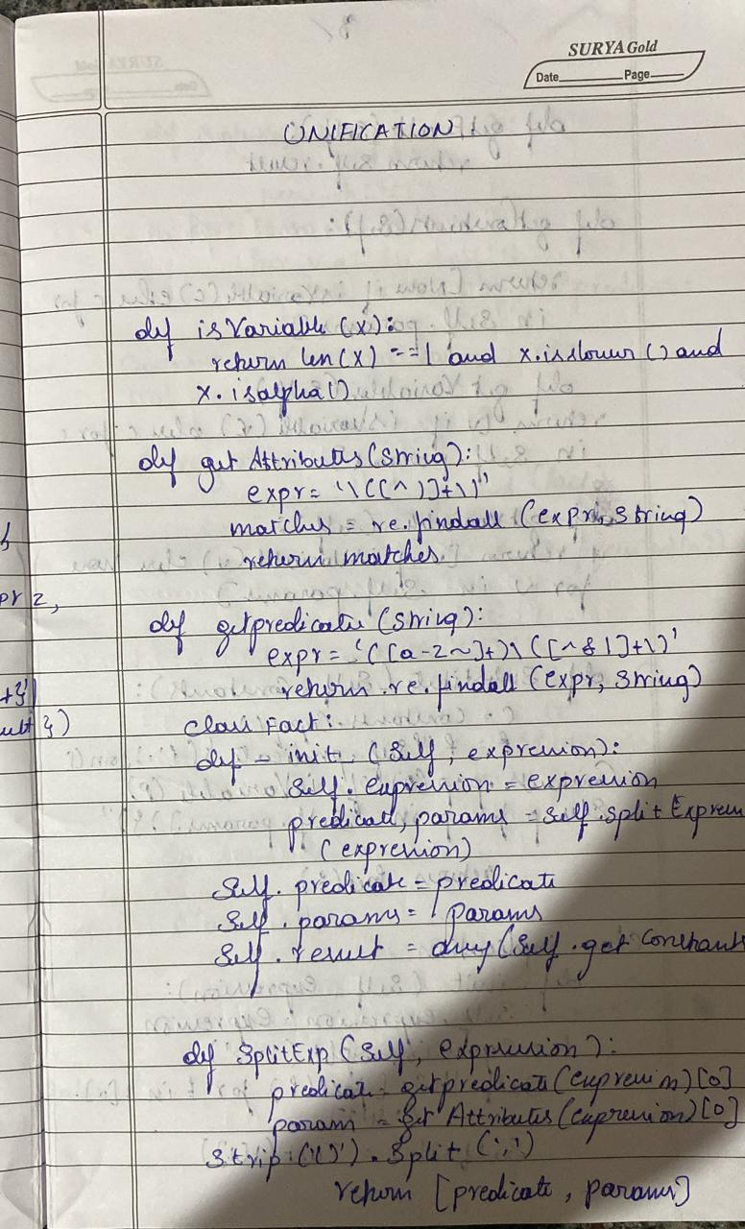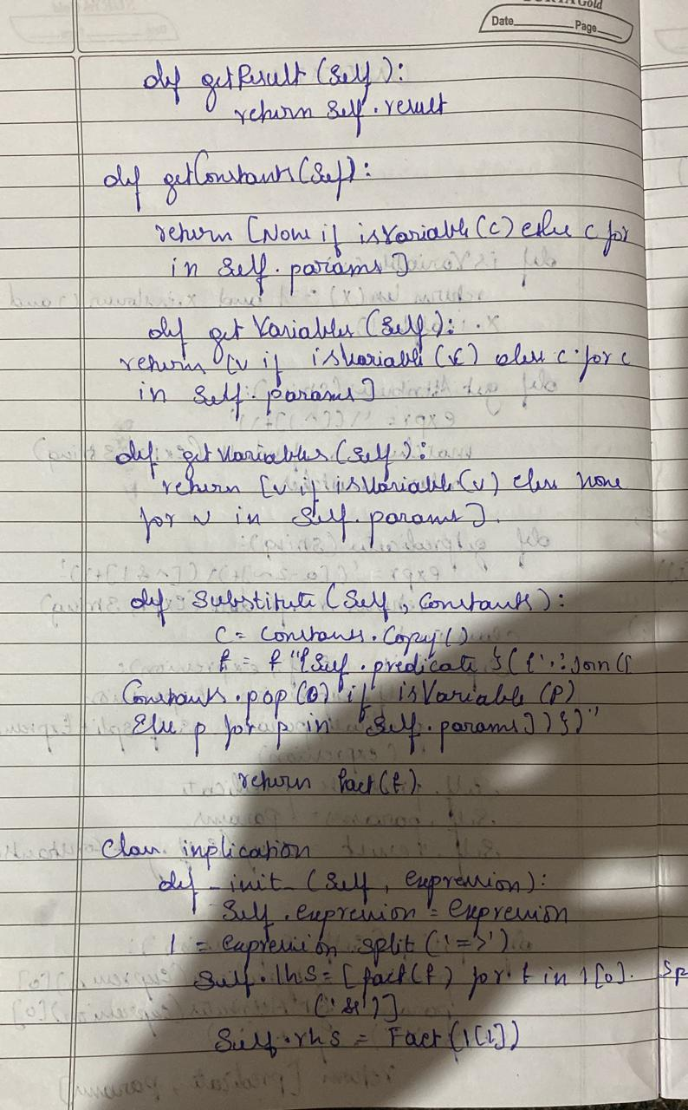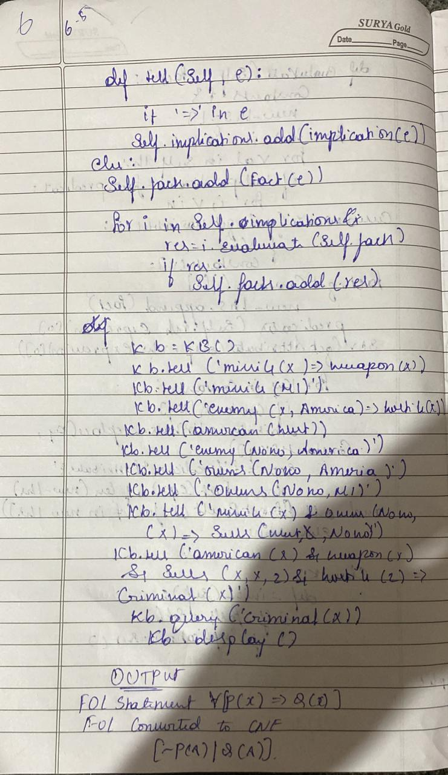

Code:

import re

def getAttributes(expression):

expression = expression.split("(")[1:]

expression = "(".join(expression)

expression = expression.split(")")[:-1]

expression = ")".join(expression)

attributes = expression.split(',')

return attributes

def getInitialPredicate(expression):

return expression.split("(")[0]

def isConstant(char):

return char.isupper() and len(char) == 1

def isVariable(char):

return char.islower() and len(char) == 1

def replaceAttributes(exp, old, new):

attributes = getAttributes(exp)

predicate = getInitialPredicate(exp)

for index, val in enumerate(attributes):

if val == old:

attributes[index] = new

return predicate + "(" + ",".join(attributes) + ")"

def apply(exp, substitutions):

for substitution in substitutions:

new, old = substitution

exp = replaceAttributes(exp, old, new)

return exp

def checkOccurs(var, exp):

if exp.find(var) == -1:

return False

return True

def getFirstPart(expression):

attributes = getAttributes(expression)

return attributes[0]

def getRemainingPart(expression):

predicate = getInitialPredicate(expression)

attributes = getAttributes(expression)

newExpression = predicate + "(" + ",".join(attributes[1:]) + ")"

return newExpression

def unify(exp1, exp2):

if exp1 == exp2:

return []

if isConstant(exp1) and isConstant(exp2):

if exp1 != exp2:

print(f"{exp1} and {exp2} are constants. Cannot be unified")

return []

if isConstant(exp1):

return [(exp1, exp2)]

if isConstant(exp2):

return [(exp2, exp1)]

if isVariable(exp1):

return [(exp2, exp1)] if not checkOccurs(exp1, exp2) else []

if isVariable(exp2):

return [(exp1, exp2)] if not checkOccurs(exp2, exp1) else []

if getInitialPredicate(exp1) != getInitialPredicate(exp2):

print("Cannot be unified as the predicates do not match!")

return []

attributeCount1 = len(getAttributes(exp1))

attributeCount2 = len(getAttributes(exp2))

if attributeCount1 != attributeCount2:

print(f"Length of attributes {attributeCount1} and {attributeCount2} do not match. Cannot be unified")

return []

head1 = getFirstPart(exp1)

head2 = getFirstPart(exp2)

initialSubstitution = unify(head1, head2)

if not initialSubstitution:

return []

if attributeCount1 == 1:

return initialSubstitution

tail1 = getRemainingPart(exp1)

tail2 = getRemainingPart(exp2)

if initialSubstitution != []:

tail1 = apply(tail1, initialSubstitution)

tail2 = apply(tail2, initialSubstitution)

remainingSubstitution = unify(tail1, tail2)

if not remainingSubstitution:

return []

return initialSubstitution + remainingSubstitution

def main():

print("Enter the first expression")

e1 = input()

print("Enter the second expression")

e2 = input()

substitutions = unify(e1, e2)

print("The substitutions are:")

print([' / '.join(substitution) for substitution in substitutions])

main()

Output:

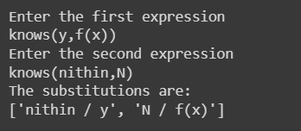

**Program-9**

Convert a given first order logic statement into Conjunctive

Normal Form (CNF).

Algorithm:

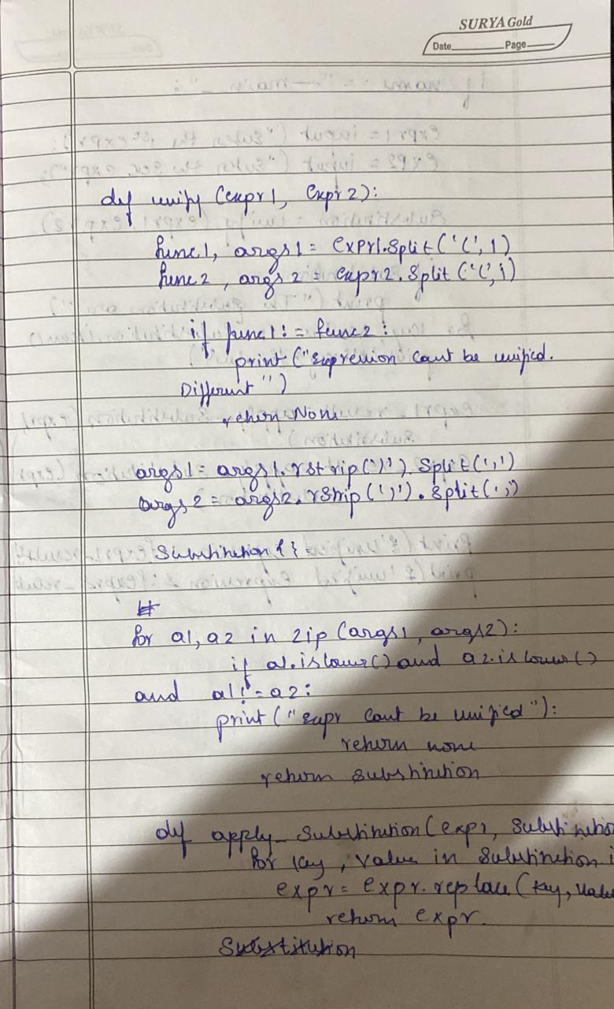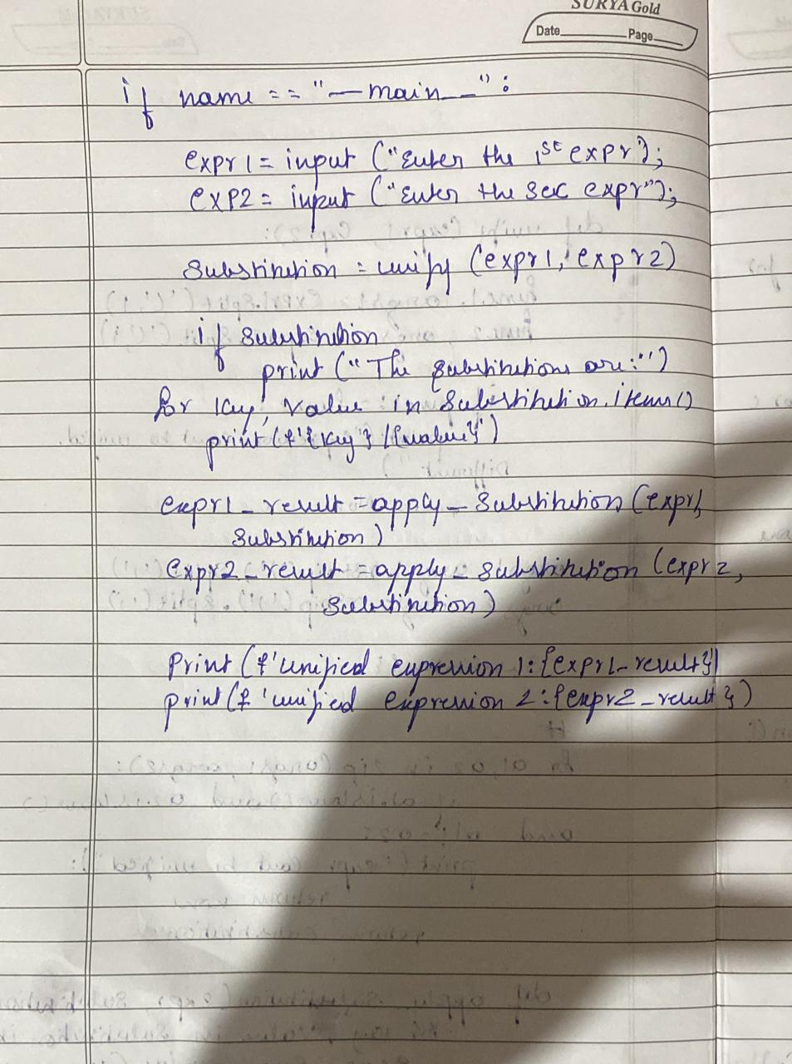

Code:

import re

def getAttributes(string):

expr = '\([^)]+\)'

matches = re.findall(expr, string)

return [m for m in str(matches) if m.isalpha()]

def getPredicates(string):

expr = '[a-z~]+\([A-Za-z,]+\)'

return re.findall(expr, string)

def DeMorgan(sentence):

string = ''.join(list(sentence).copy())

string = string.replace('~~','')

flag = '[' in string

string = string.replace('~[','')

string = string.strip(']')

for predicate in getPredicates(string):

string = string.replace(predicate, f'~{predicate}')

s = list(string)

for i, c in enumerate(string):

if c == 'V':

s[i] = '^'

elif c == '^':

s[i] = 'V'

string = ''.join(s)

string = string.replace('~~','')

return f'[{string}]' if flag else string

def Skolemization(sentence):

SKOLEM_CONSTANTS = [f'{chr(c)}' for c in range(ord('A'), ord('Z')+1)]

statement = ''.join(list(sentence).copy())

matches = re.findall('[∀∃].', statement)

for match in matches[::-1]:

statement = statement.replace(match, '')

statements = re.findall('\[\[[^]]+\]]', statement)

for s in statements:

statement = statement.replace(s, s[1:-1])

for predicate in getPredicates(statement):

attributes = getAttributes(predicate)

if ''.join(attributes).islower():

statement = statement.replace(match[1],SKOLEM_CONSTANTS.pop(0))

else:

aL = [a for a in attributes if a.islower()]

aU = [a for a in attributes if not a.islower()][0]

statement = statement.replace(aU, f'{SKOLEM_CONSTANTS.pop(0)}({aL[0] if len(aL) else match[1]})')

return statement

def fol_to_cnf(fol):

statement = fol.replace("<=>", "_")

while '_' in statement:

i = statement.index('_')

new_statement = '[' + statement[:i] + '=>' + statement[i+1:] + ']^['+ statement[i+1:] + '=>' + statement[:i] + ']'

statement = new_statement

statement = statement.replace("=>", "-")

expr = '\[([^]]+)\]'

statements = re.findall(expr, statement)

for i, s in enumerate(statements):

if '[' in s and ']' not in s:

statements[i] += ']'

for s in statements:

statement = statement.replace(s, fol_to_cnf(s))

while '-' in statement:

i = statement.index('-')

br = statement.index('[') if '[' in statement else 0

new_statement = '~' + statement[br:i] + 'V' + statement[i+1:]

statement = statement[:br] + new_statement if br > 0 else new_statement

while '~∀' in statement:

i = statement.index('~∀')

statement = list(statement)

statement[i], statement[i+1], statement[i+2] = '∃', statement[i+2], '~'

statement = ''.join(statement)

while '~∃' in statement:

i = statement.index('~∃')

s = list(statement)

s[i], s[i+1], s[i+2] = '∀', s[i+2], '~'

statement = ''.join(s)

statement = statement.replace('~[∀','[~∀')

statement = statement.replace('~[∃','[~∃')

expr = '(~[∀V∃].)'

statements = re.findall(expr, statement)

for s in statements:

statement = statement.replace(s, fol_to_cnf(s))

expr = '~\[[^]]+\]'

statements = re.findall(expr, statement)

for s in statements:

statement = statement.replace(s, DeMorgan(s))

return statement

def main():

print("Enter FOL:")

fol = input()

print("The CNF form of the given FOL is: ")

print(Skolemization(fol_to_cnf(fol)))

main()

Output:

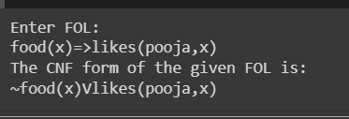

**Program-10**

Create a knowledge base consisting of first order logic statements and prove the given query using forward reasoning.

Algorithm:

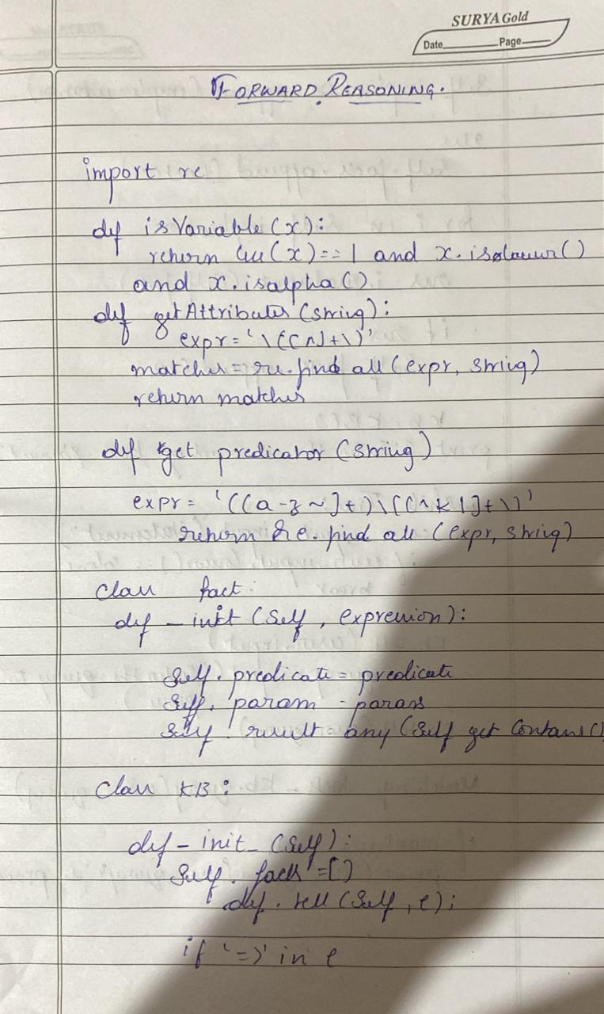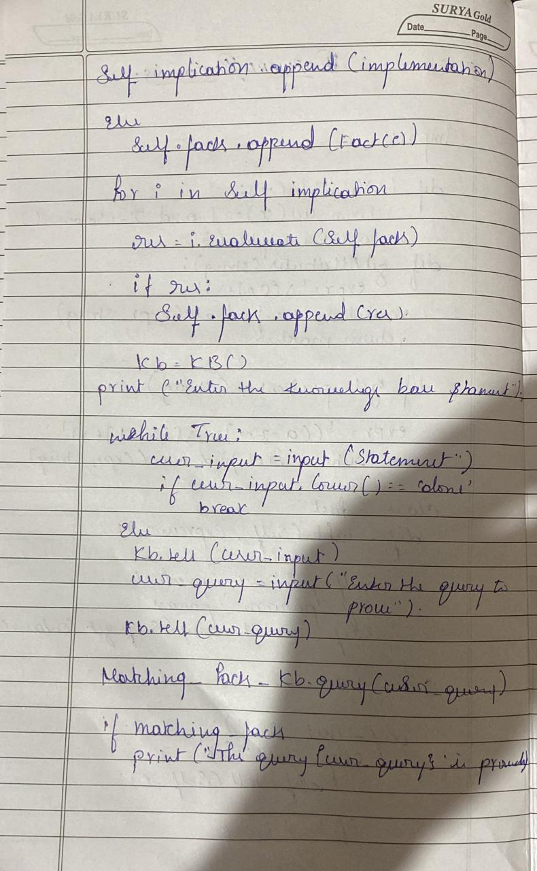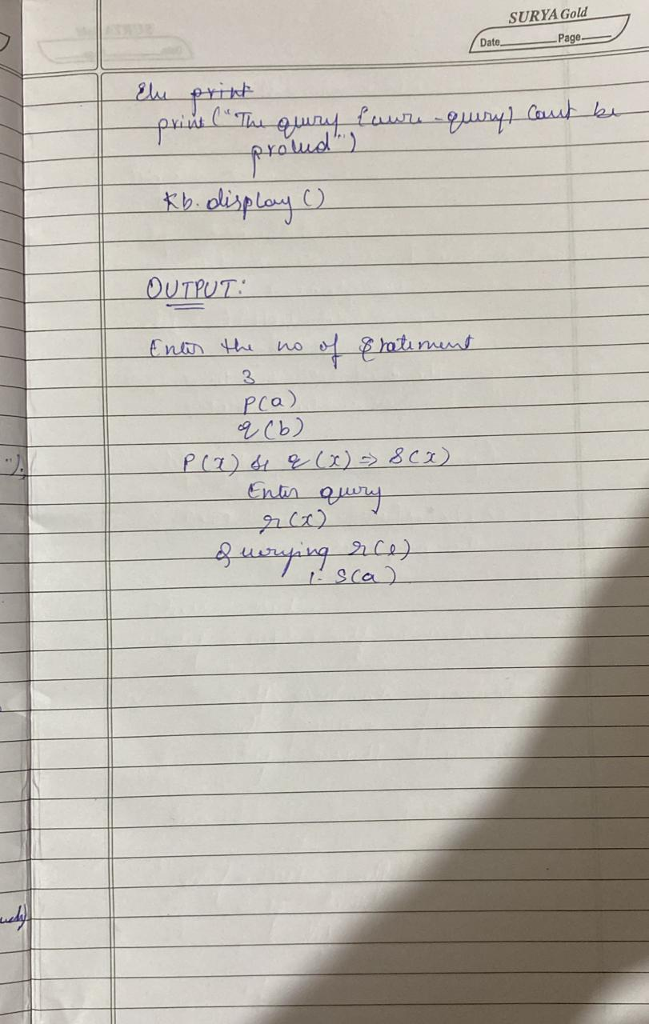

Code:

import re

def isVariable(x):

return len(x) == 1 and x.islower() and x.isalpha()

def getAttributes(string):

expr = '\([^)]+\)'

matches = re.findall(expr, string)

return matches

def getPredicates(string):

expr = '([a-z~]+)\([^&|]+\)'

return re.findall(expr, string)

class Fact:

def __init__(self, expression):

self.expression = expression

predicate, params = self.splitExpression(expression)

self.predicate = predicate

self.params = params

self.result = any(self.getConstants())

def splitExpression(self, expression):

predicate = getPredicates(expression)[0]

params = getAttributes(expression)[0].strip('()').split(',')

return [predicate, params]

def getResult(self):

return self.result

def getConstants(self):

return [None if isVariable(c) else c for c in self.params]

def getVariables(self):

return [v if isVariable(v) else None for v in self.params]

def substitute(self, constants):

c = constants.copy()

f = f"{self.predicate}({','.join([constants.pop(0) if isVariable(p) else p for p in self.params])})"

return Fact(f)

class Implication:

def __init__(self, expression):

self.expression = expression

l = expression.split('=>')

self.lhs = [Fact(f) for f in l[0].split('&')]

self.rhs = Fact(l[1])

def evaluate(self, facts):

constants = {}

new_lhs = []

for fact in facts:

for val in self.lhs:

if val.predicate == fact.predicate:

for i, v in enumerate(val.getVariables()):

if v:

constants[v] = fact.getConstants()[i]

new_lhs.append(fact)

predicate, attributes = getPredicates(self.rhs.expression)[0], str(getAttributes(self.rhs.expression)[0])

for key in constants:

if constants[key]:

attributes = attributes.replace(key, constants[key])

expr = f'{predicate}{attributes}'

return Fact(expr) if len(new_lhs) and all([f.getResult() for f in new_lhs]) else None

class KB:

def __init__(self):

self.facts = set()

self.implications = set()

def tell(self, e):

if '=>' in e:

self.implications.add(Implication(e))

else:

self.facts.add(Fact(e))

for i in self.implications:

res = i.evaluate(self.facts)

if res:

self.facts.add(res)

def query(self, e):

facts = set([f.expression for f in self.facts])

i = 1

print(f'Querying {e}:')

for f in facts:

if Fact(f).predicate == Fact(e).predicate:

print(f'\t{i}. {f}')

i += 1

def display(self):

print("All facts: ")

for i, f in enumerate(set([f.expression for f in self.facts])):

print(f'\t{i+1}. {f}')

def main():

kb = KB()

print("Enter KB: (enter e to exit)")

while True:

t = input()

if(t == 'e'):

break

kb.tell(t)

print("Enter Query:")

q = input()

kb.query(q)

kb.display()

main()

Output:

